FULL CUSTOM DESIGN USING CADENCE

OBJECTIVE

- To gain hands on experience in full custom VLSI design by performing schematic design, layout implementation, and pre-layout and post layout simulation of the D - Latch, D – Flip Flop, 8-Bit Counter, 8- Bit Register and 4-Bit CLA to understand CMOS digital circuit performance and verification flow.

2-Input OR Gate

➢ SCHEMATIC
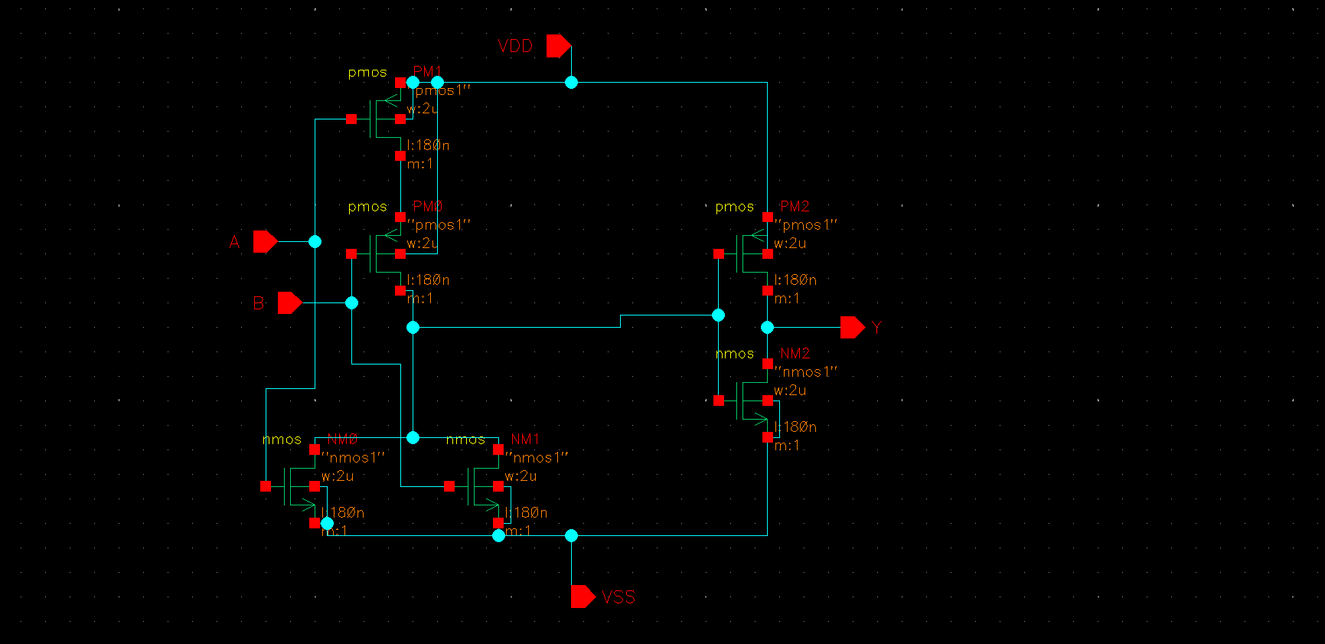
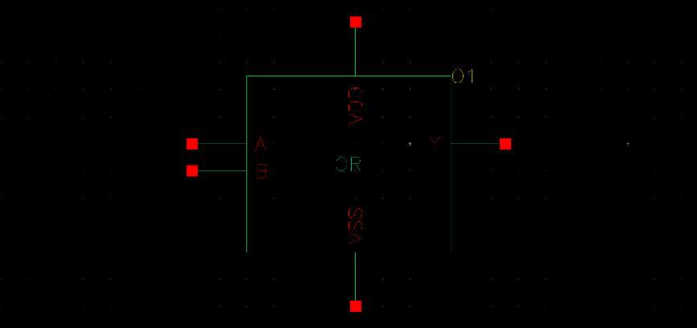

➢ TEST BENCH
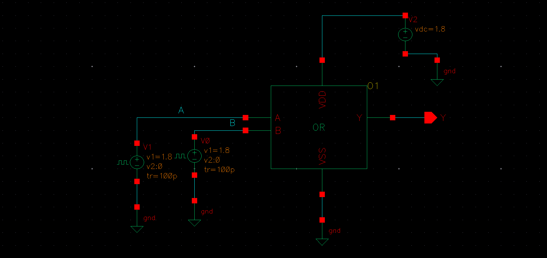

➢ PRE WAVE SIMULATION WAVEFORM
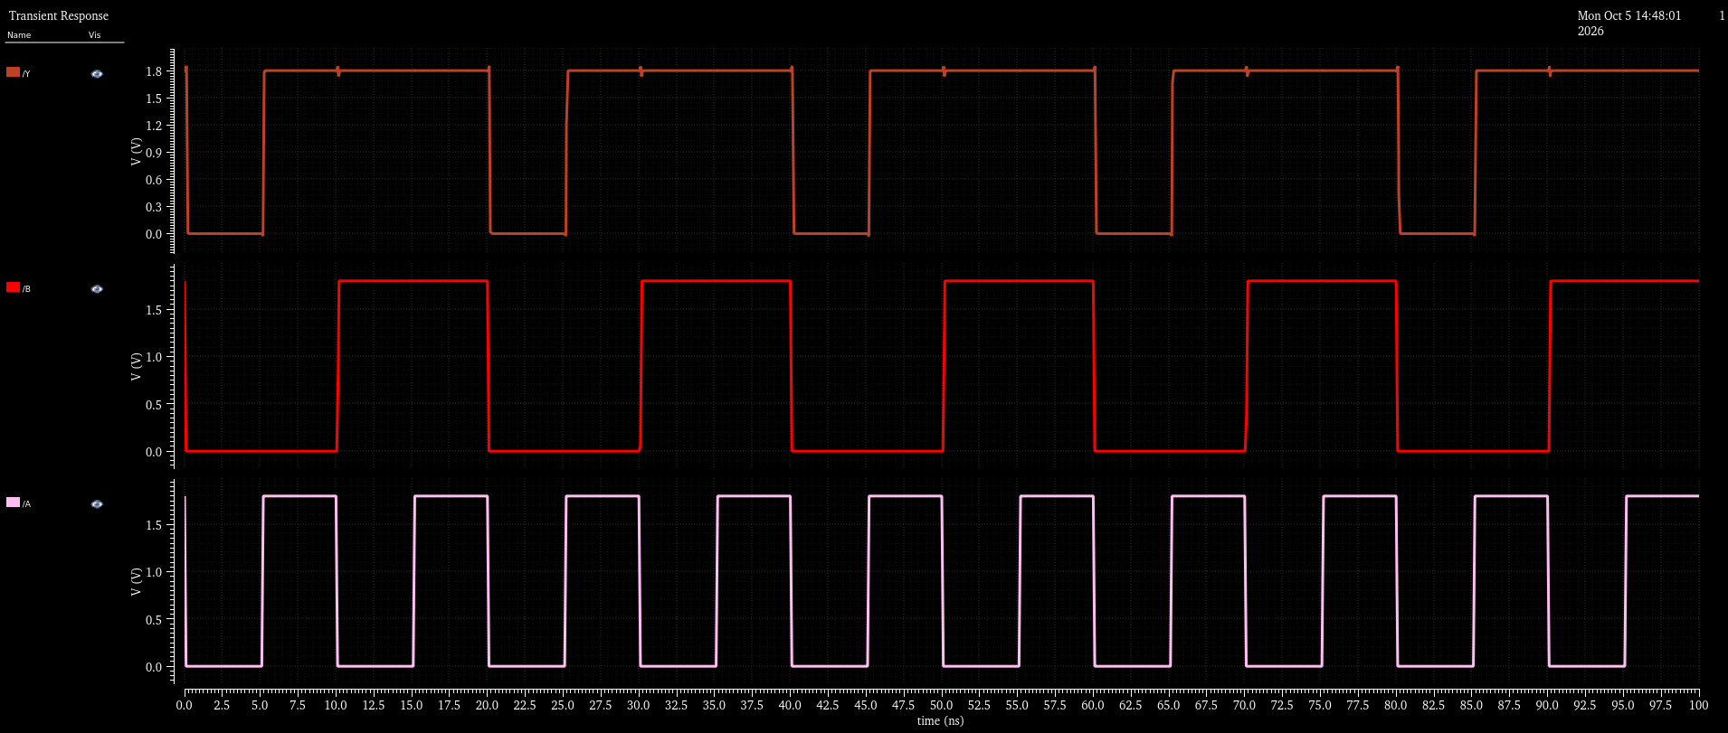

3-Input OR Gate

➢ SCHEMATIC
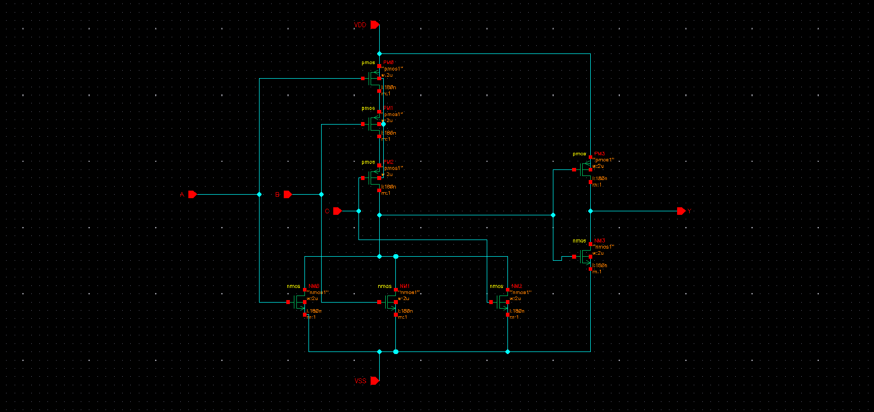

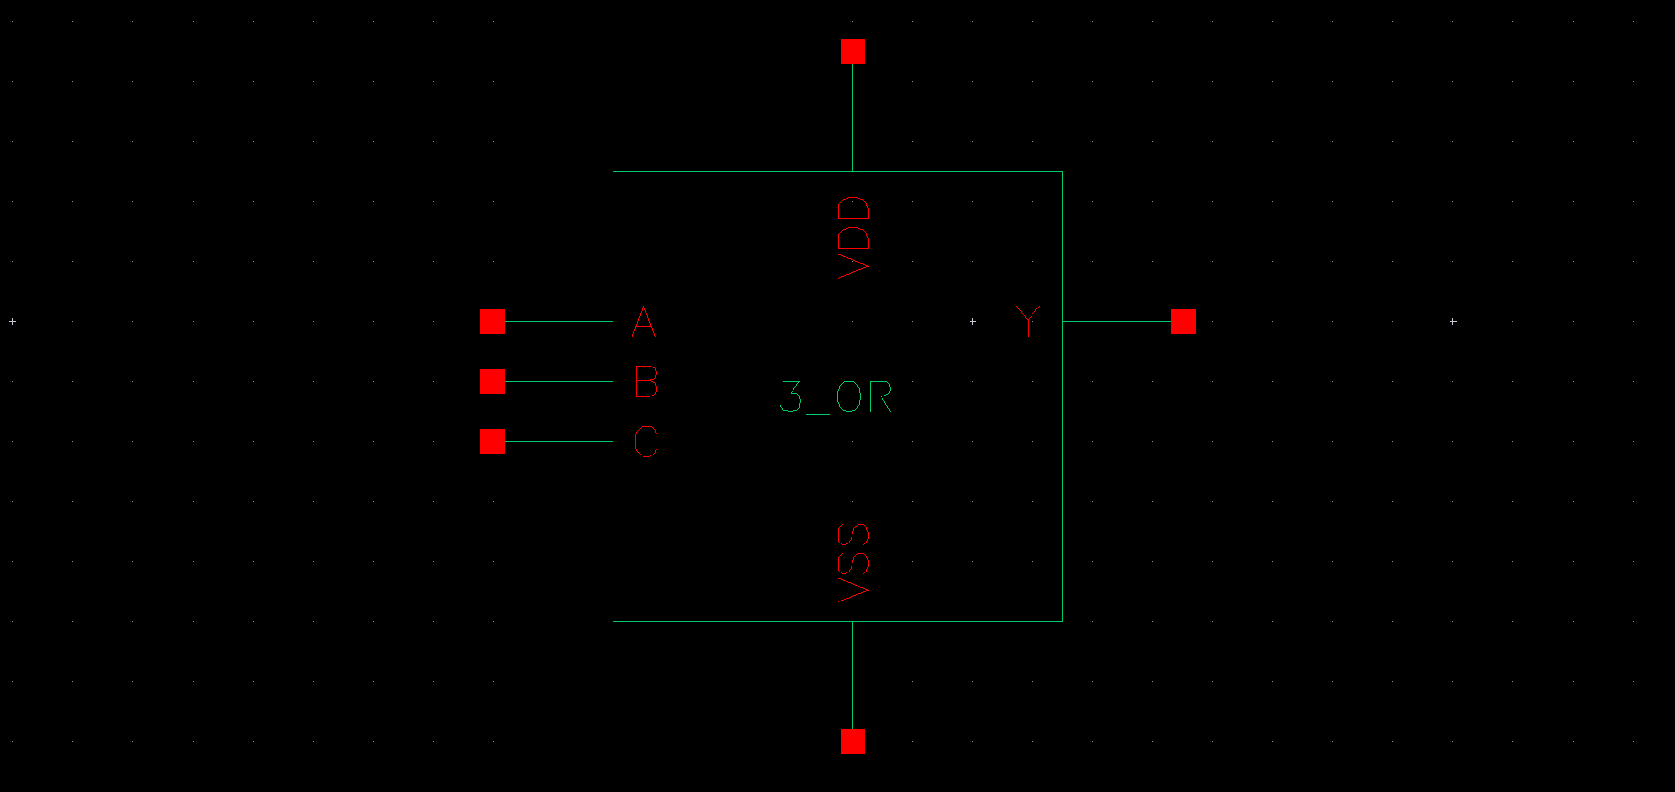

➢ TEST BENCH
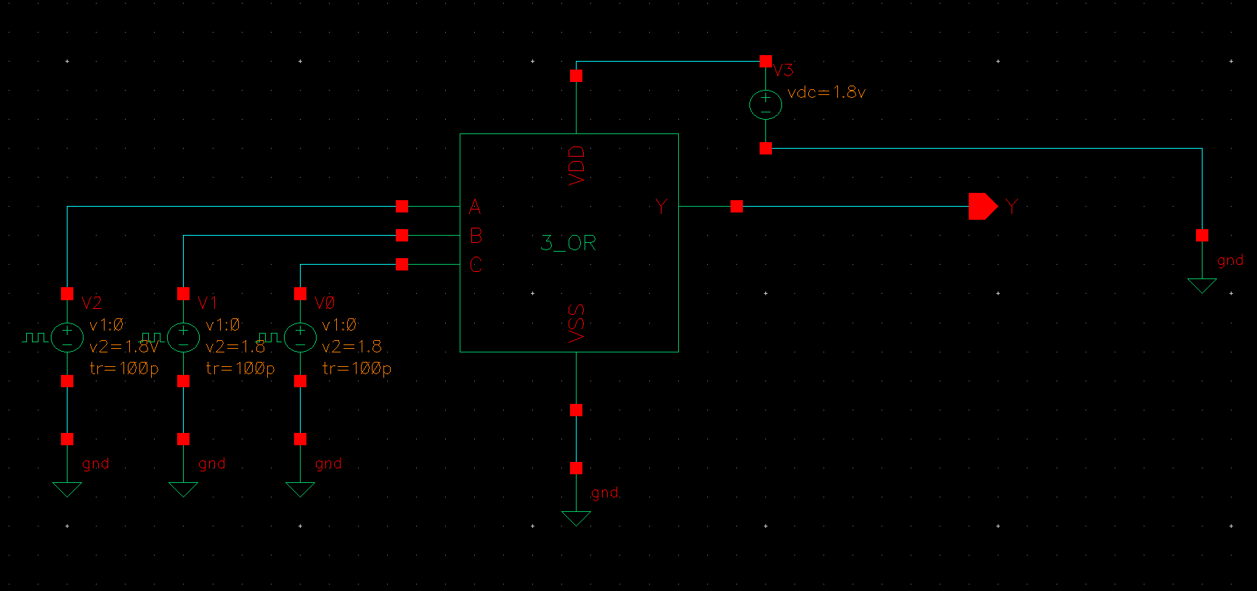

➢ PRE WAVE SIMULATION WAVEFORM
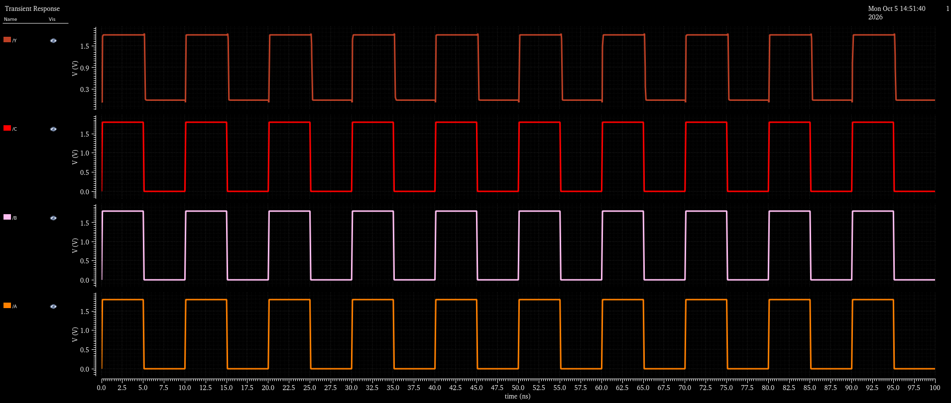

4-Input OR Gate

➢ SCHEMATIC
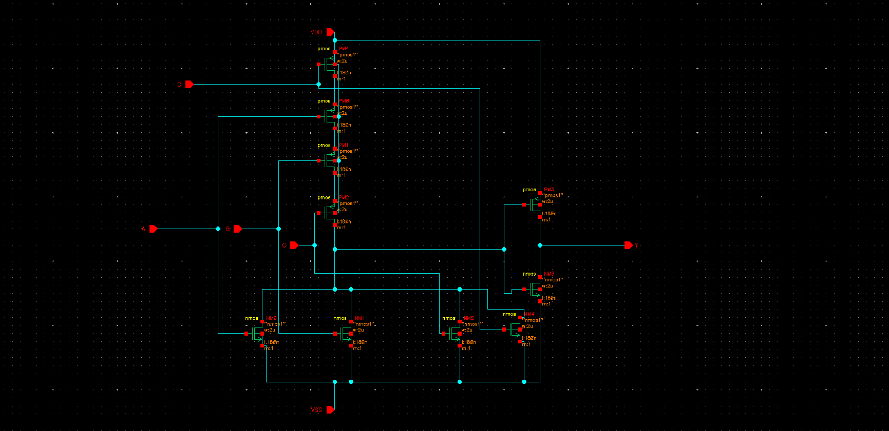

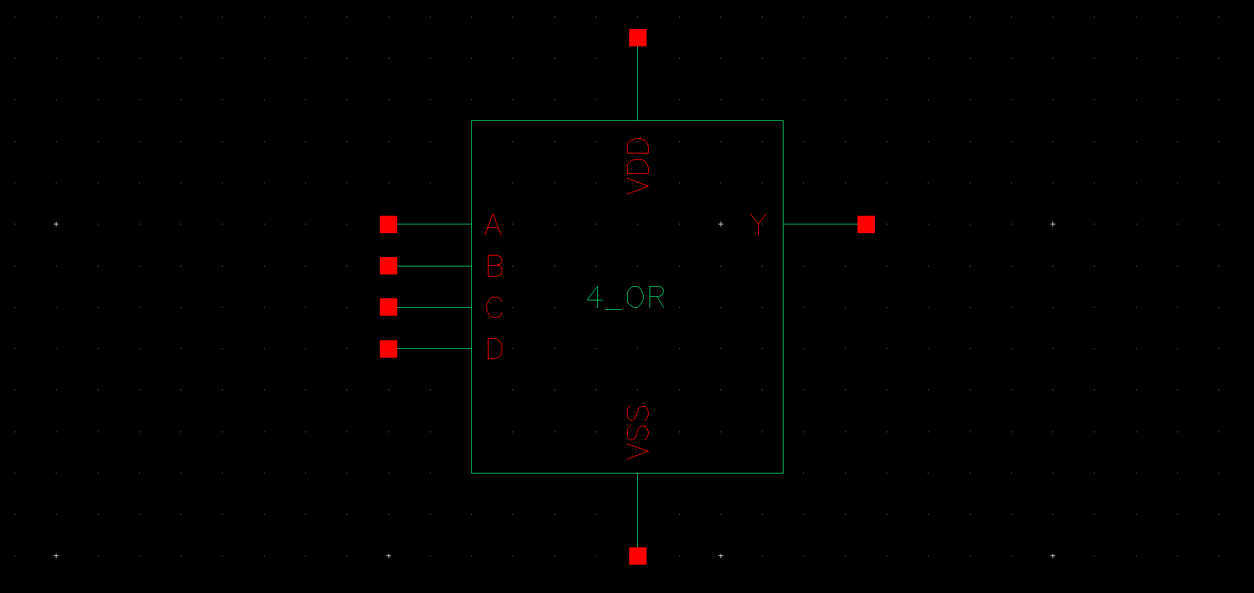

➢ TEST BENCH
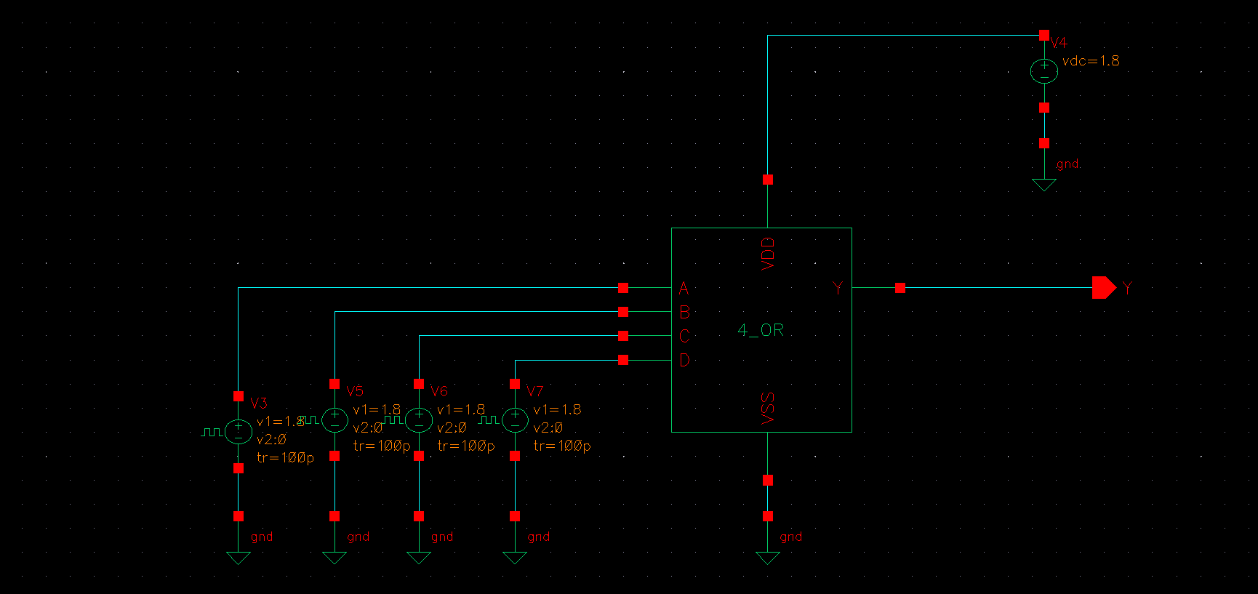

➢ PRE WAVE SIMULATION WAVEFORM
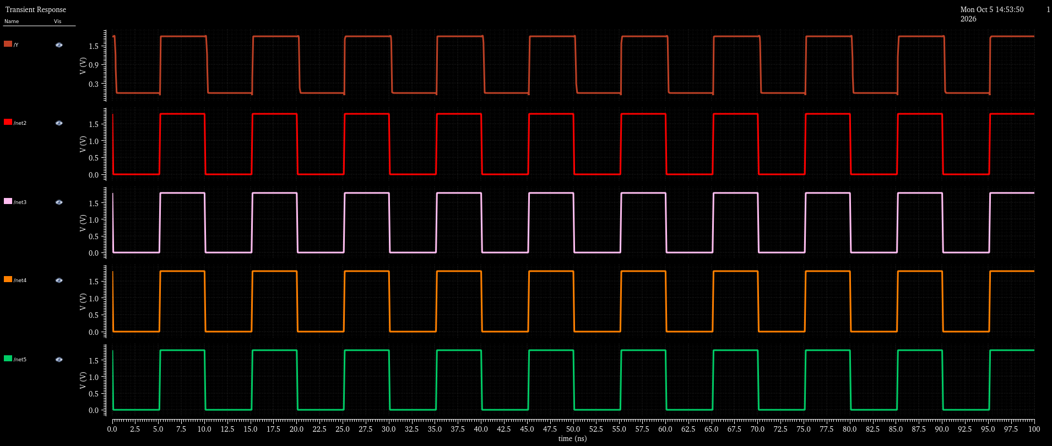

5-Input OR Gate

➢ SCHEMATIC
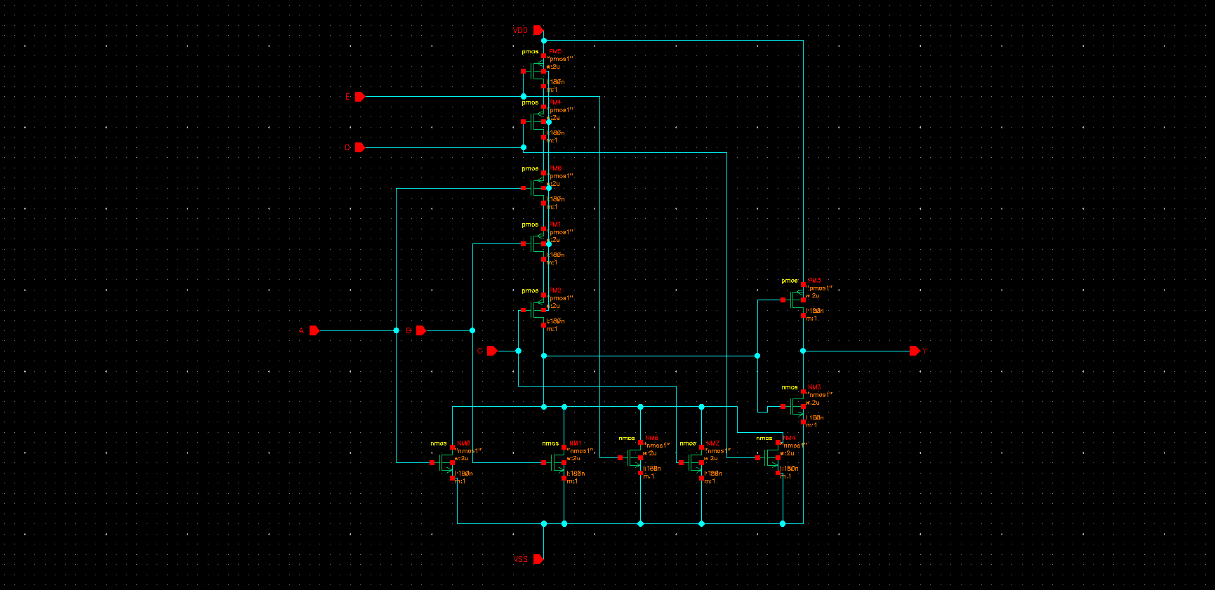
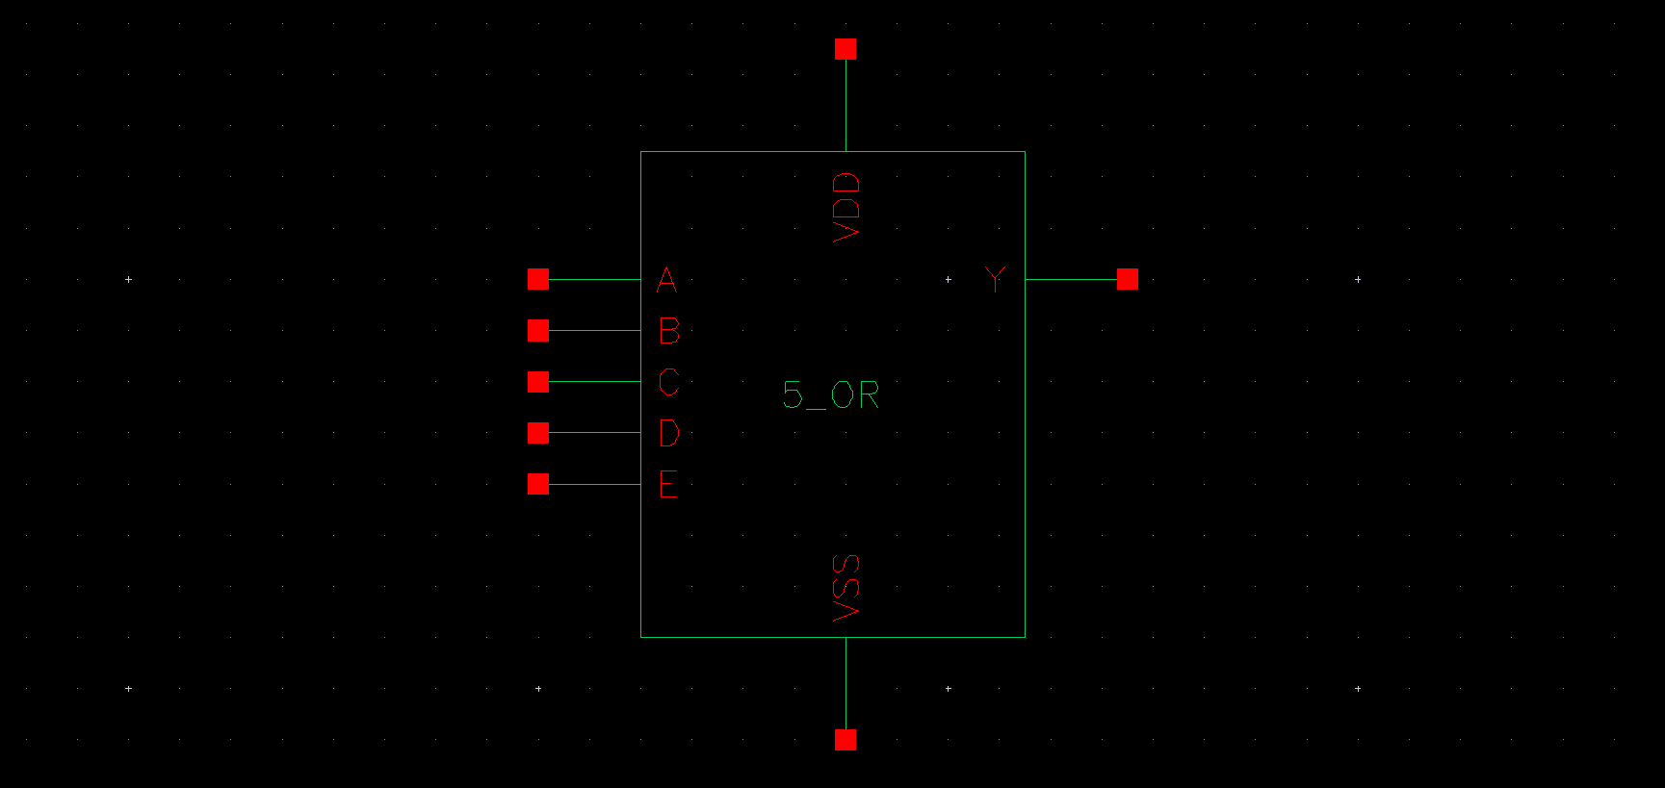

➢ TEST BENCH
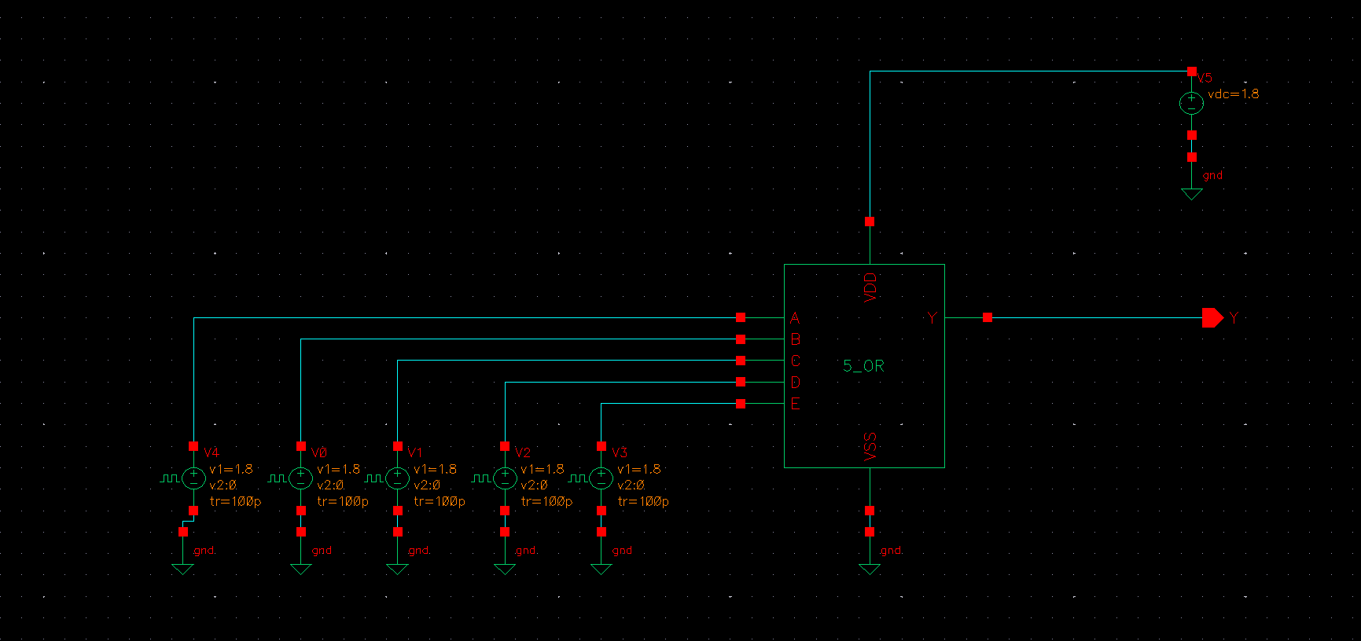

➢ PRE WAVE SIMULATION WAVEFORM
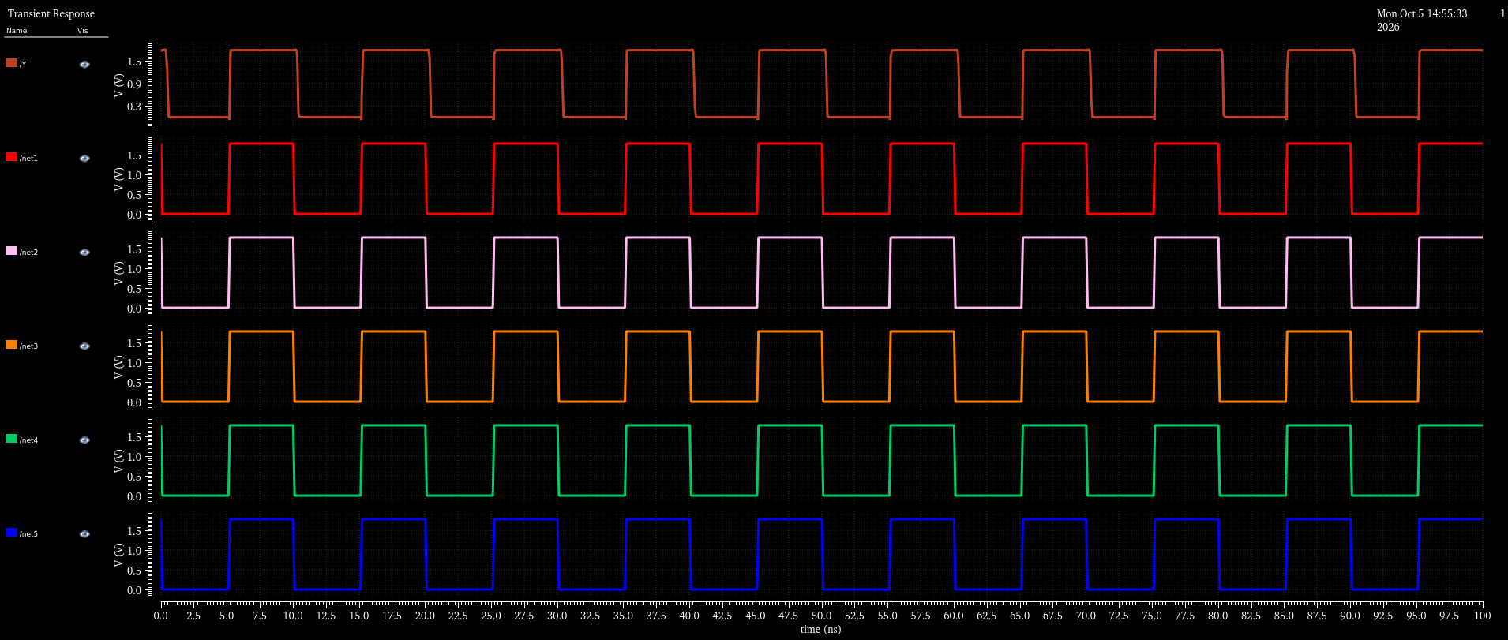

2-Input AND Gate

➢ SCHEMATIC
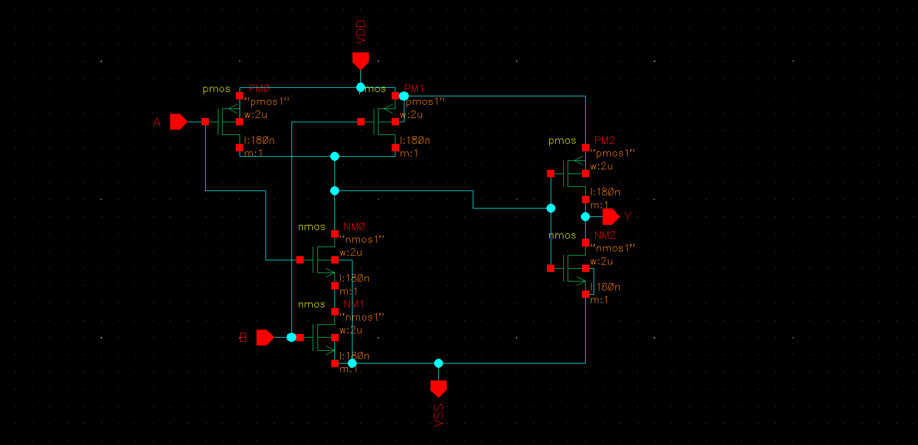

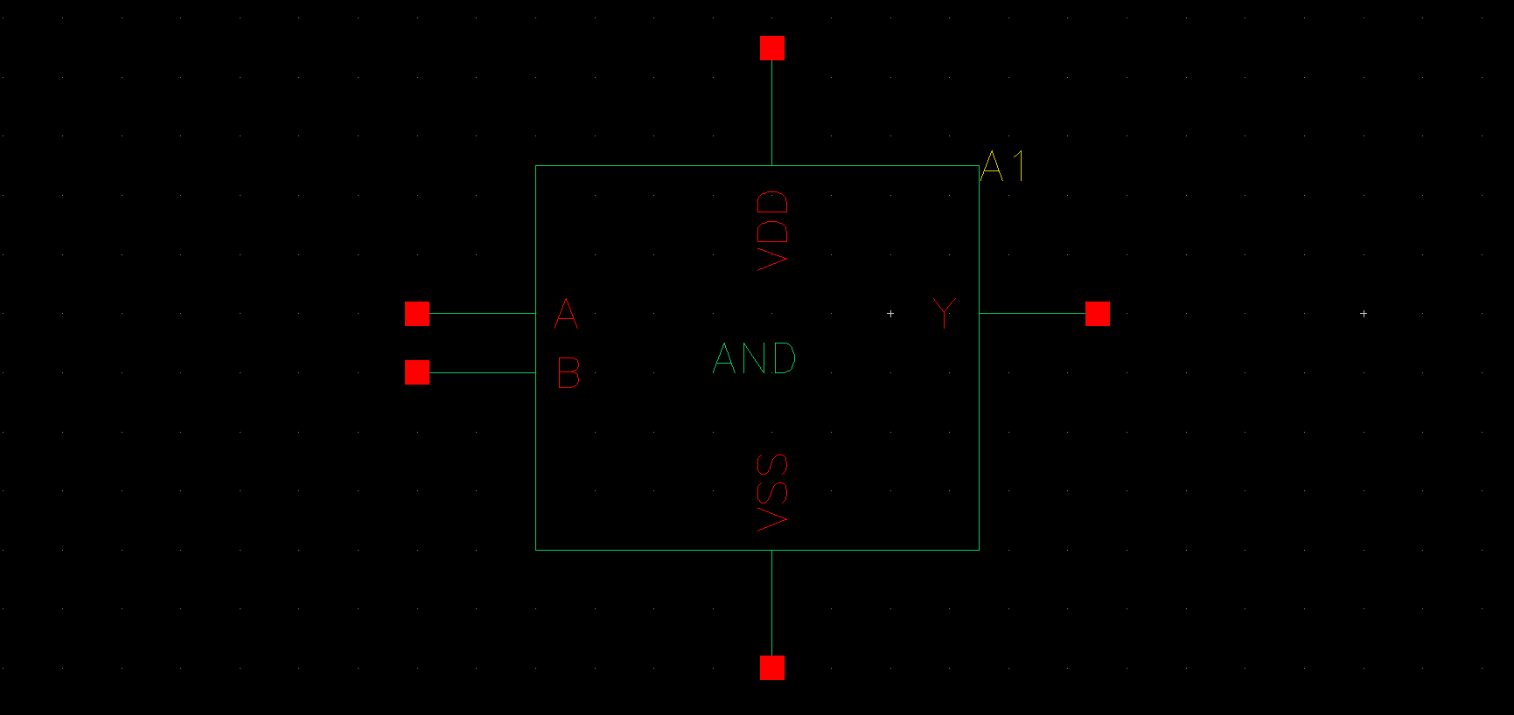

➢ TEST BENCH
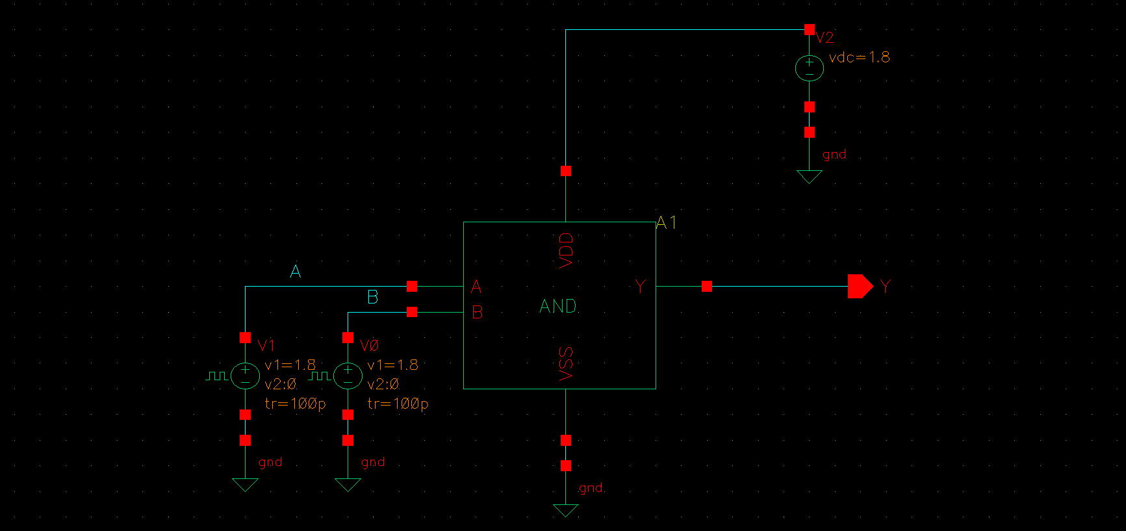

➢ PRE WAVE SIMULATION WAVEFORM
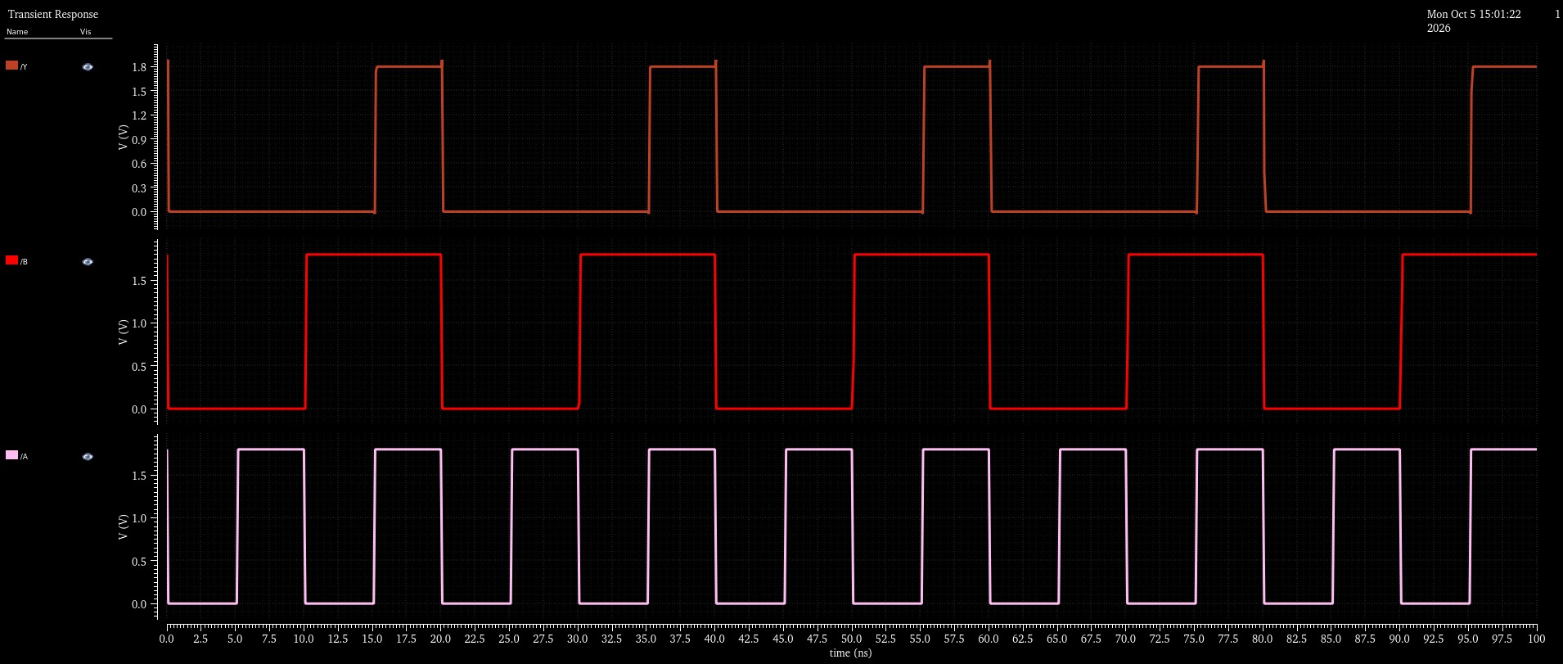

3-Input AND Gate

➢ SCHEMATIC
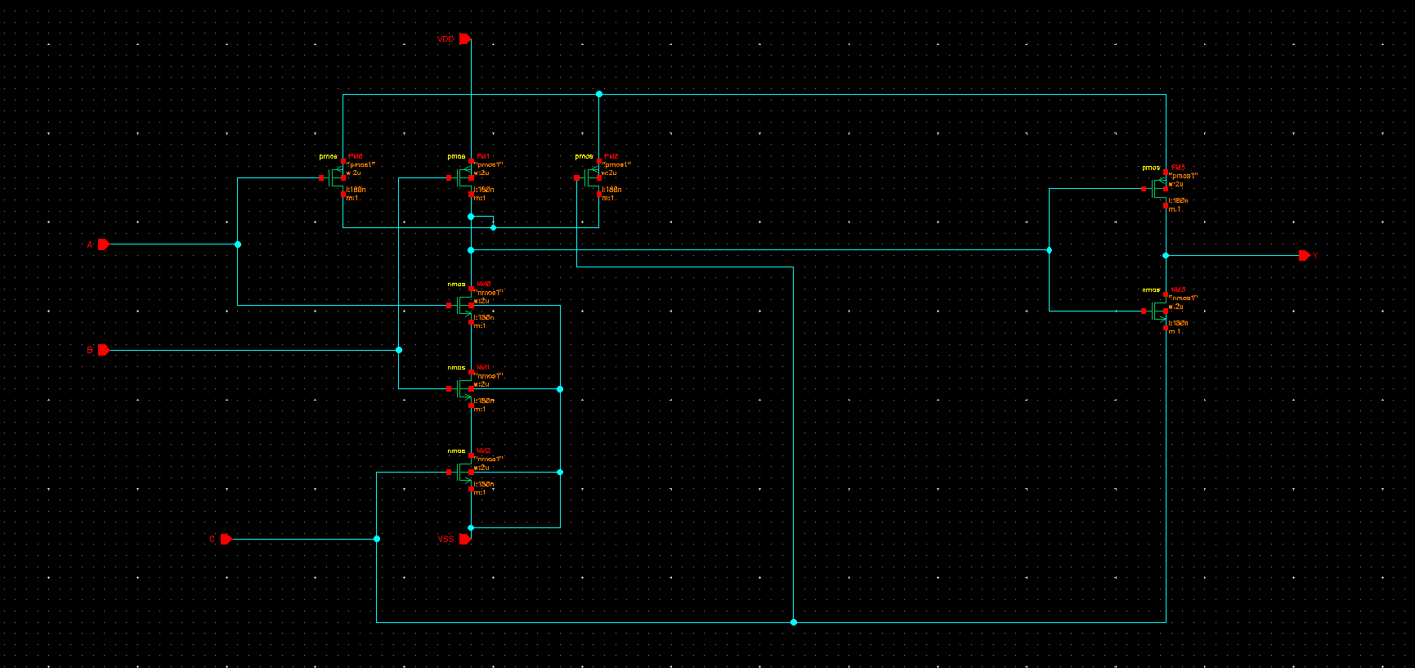

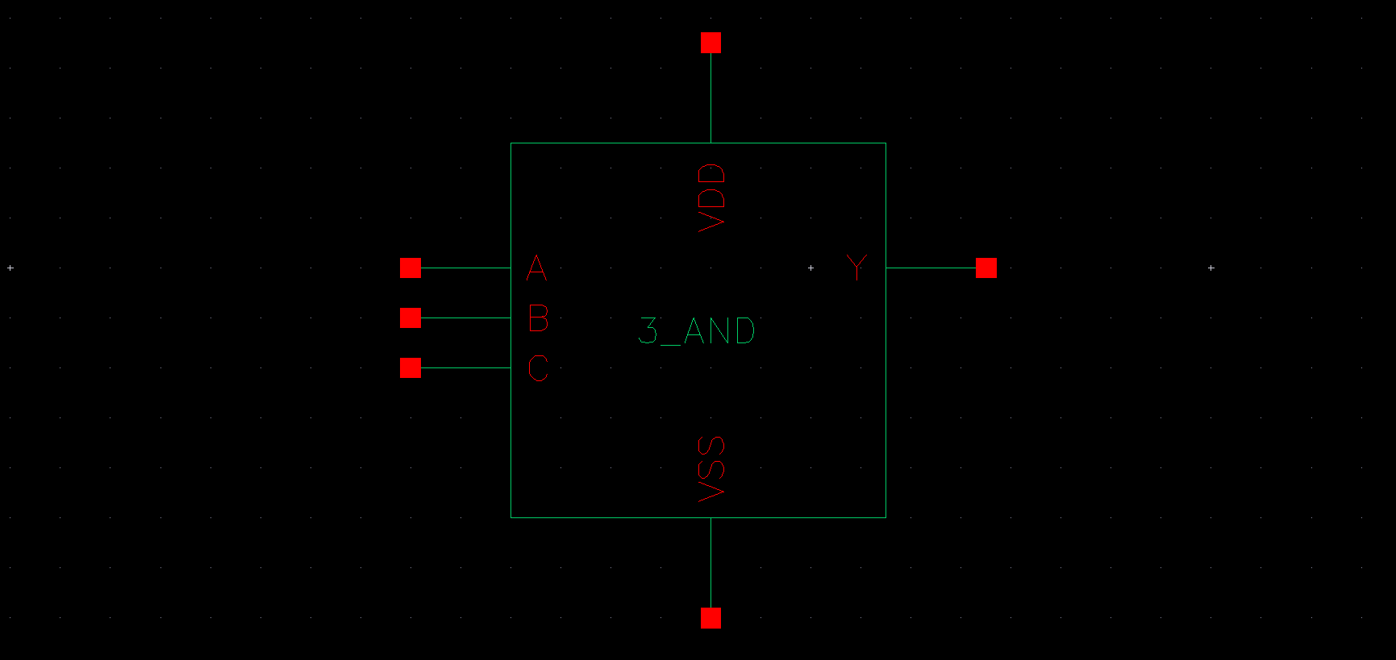

➢ TEST BENCH
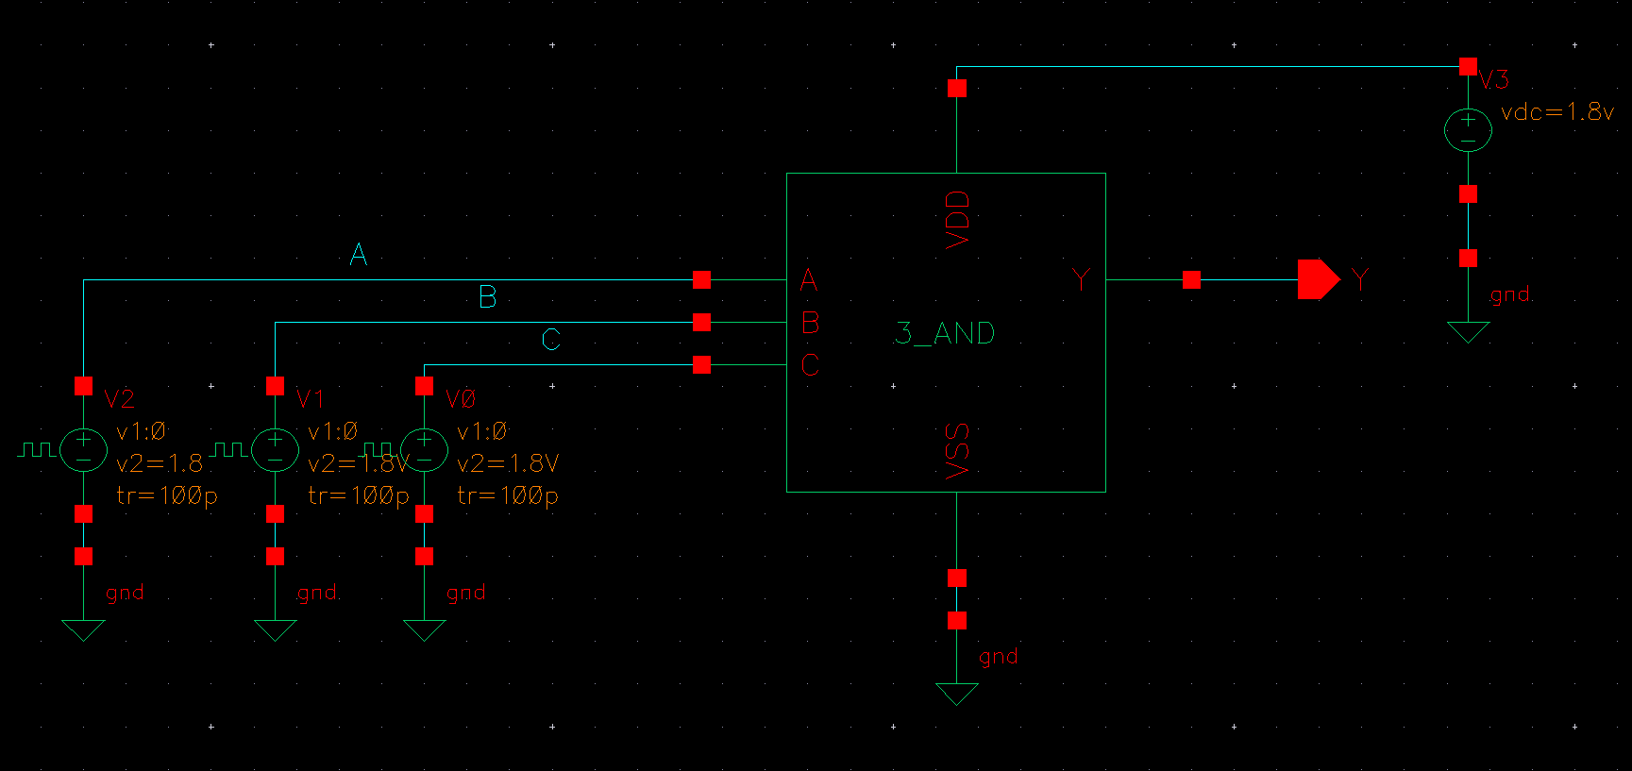

➢ PRE WAVE SIMULATION WAVEFORM
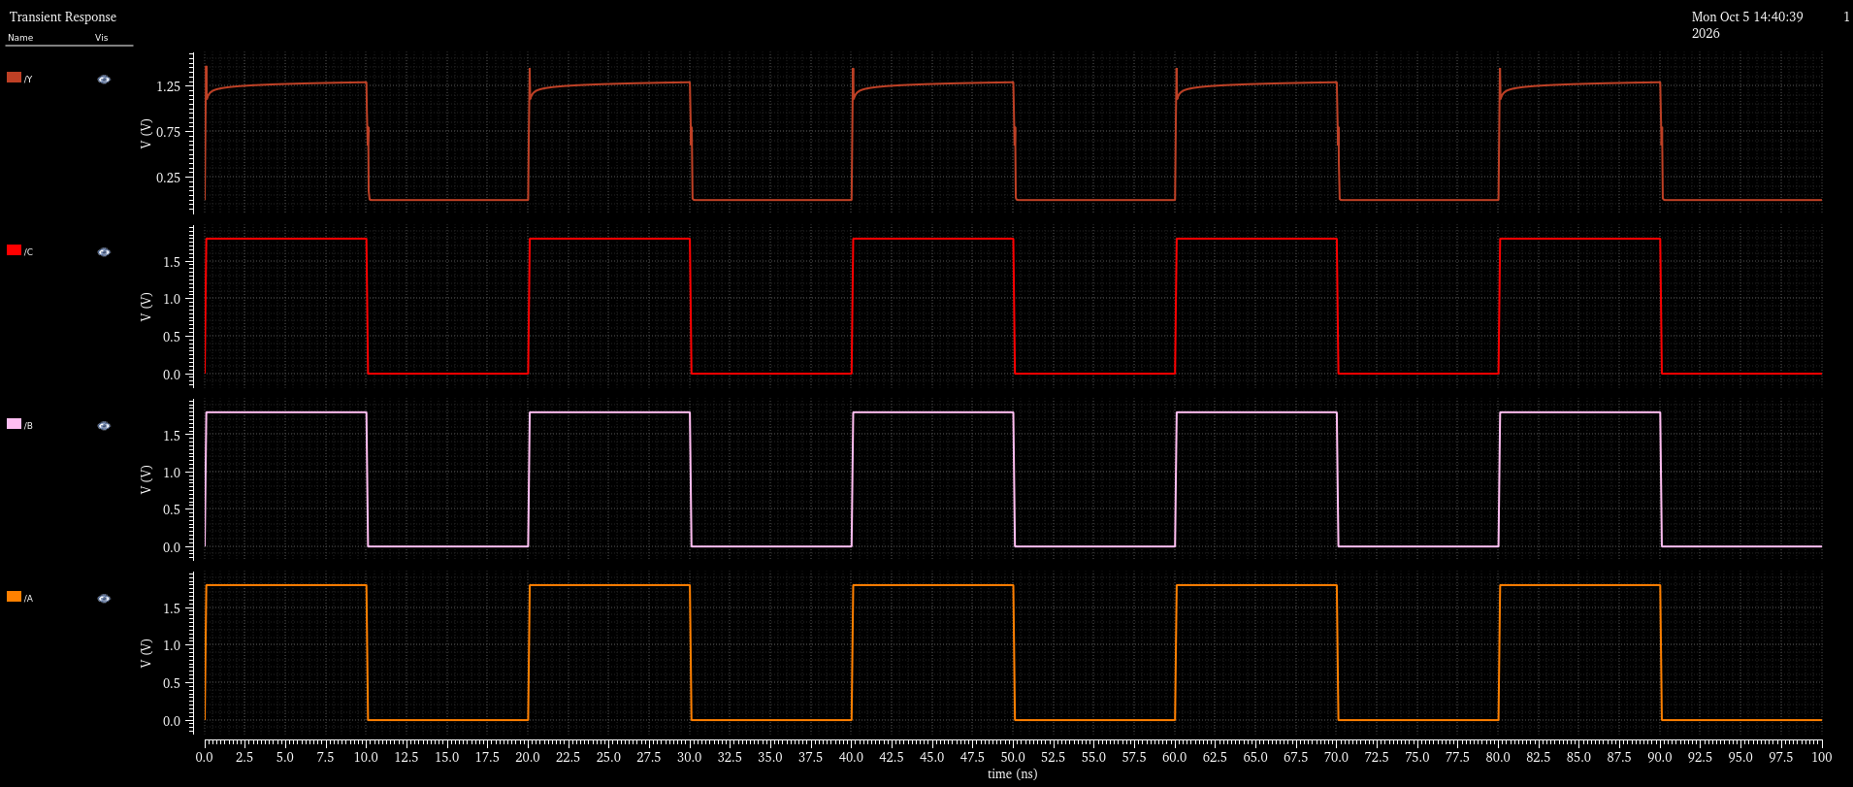

4-Input AND Gate

➢ SCHEMATIC
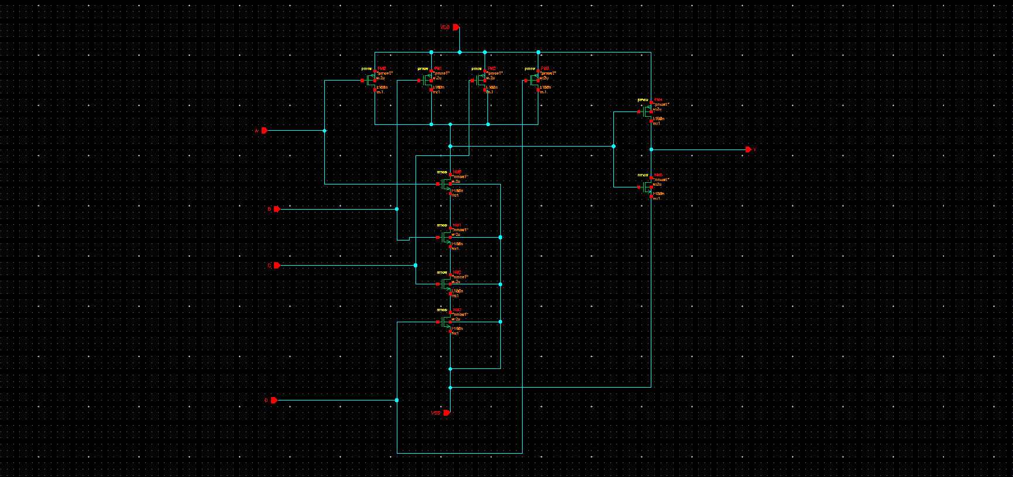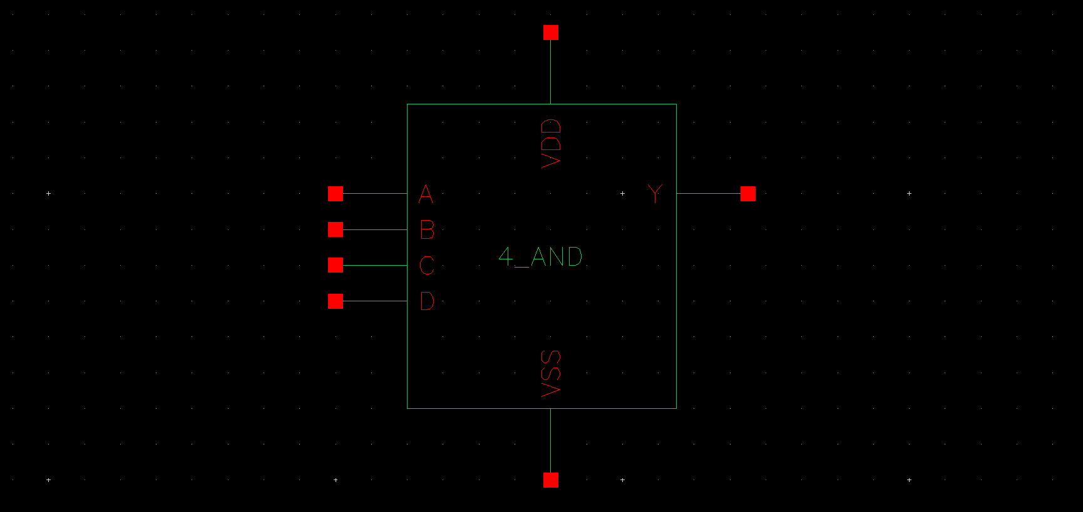

➢ TEST BENCH
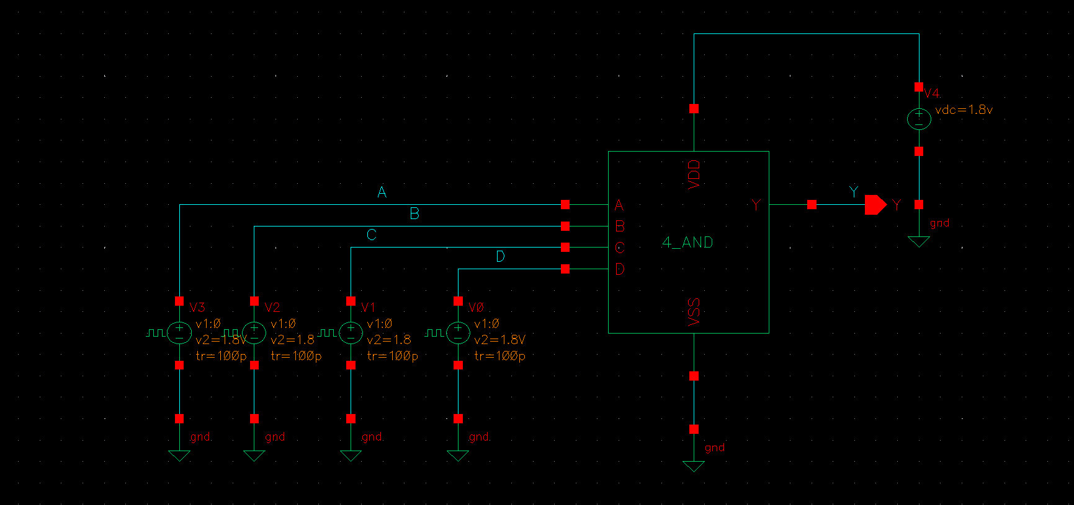

➢ PRE WAVE SIMULATION WAVEFORM
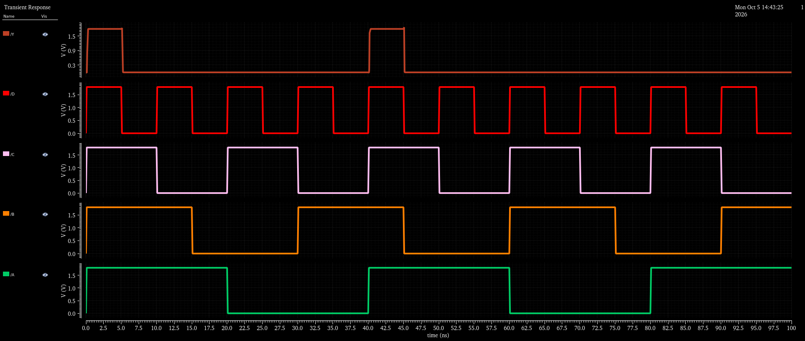

5-Input AND Gate

➢ SCHEMATIC
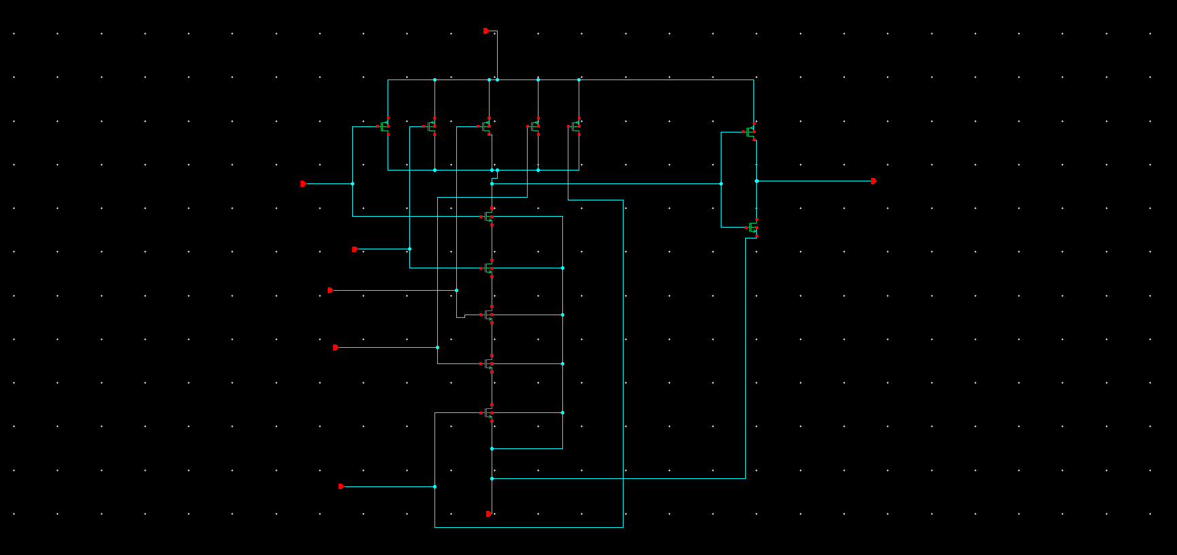
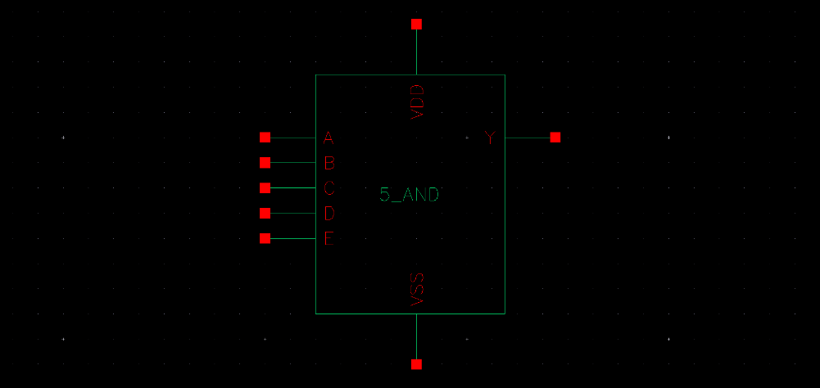

➢ TEST BENCH
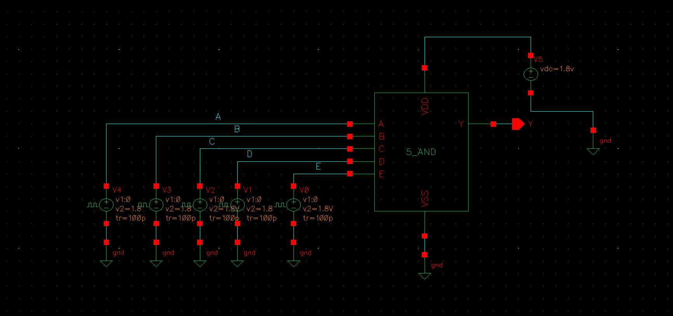

➢ PRE WAVE SIMULATION WAVEFORM
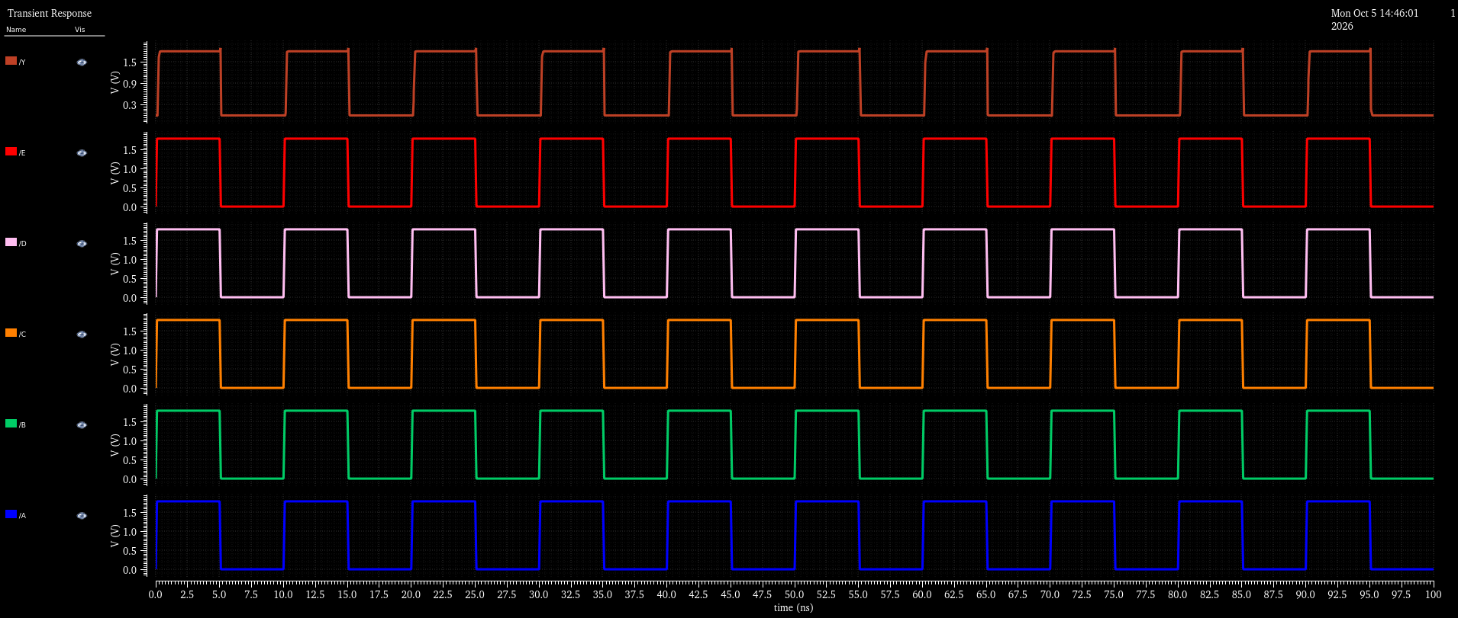

3-Input XOR Gate

➢ SCHEMATIC
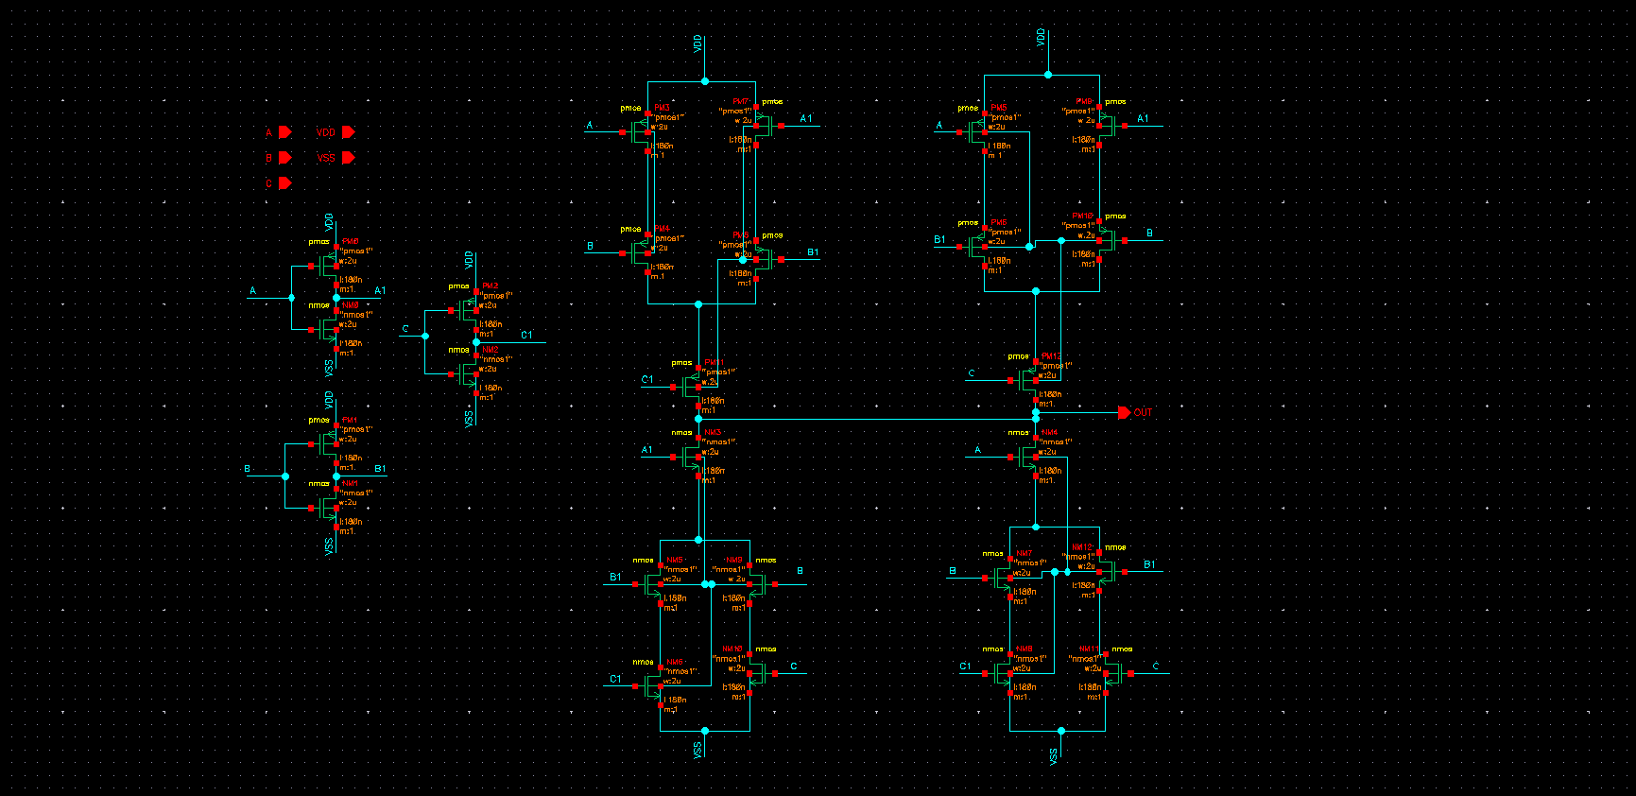

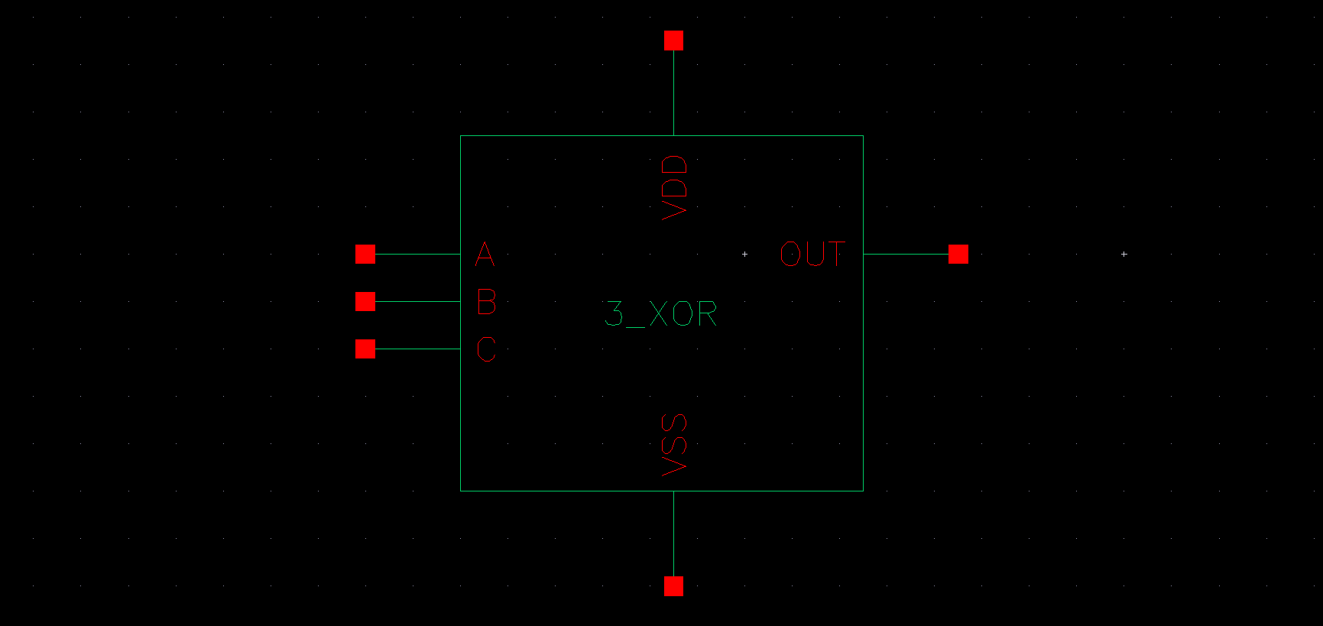
➢ TEST BENCH
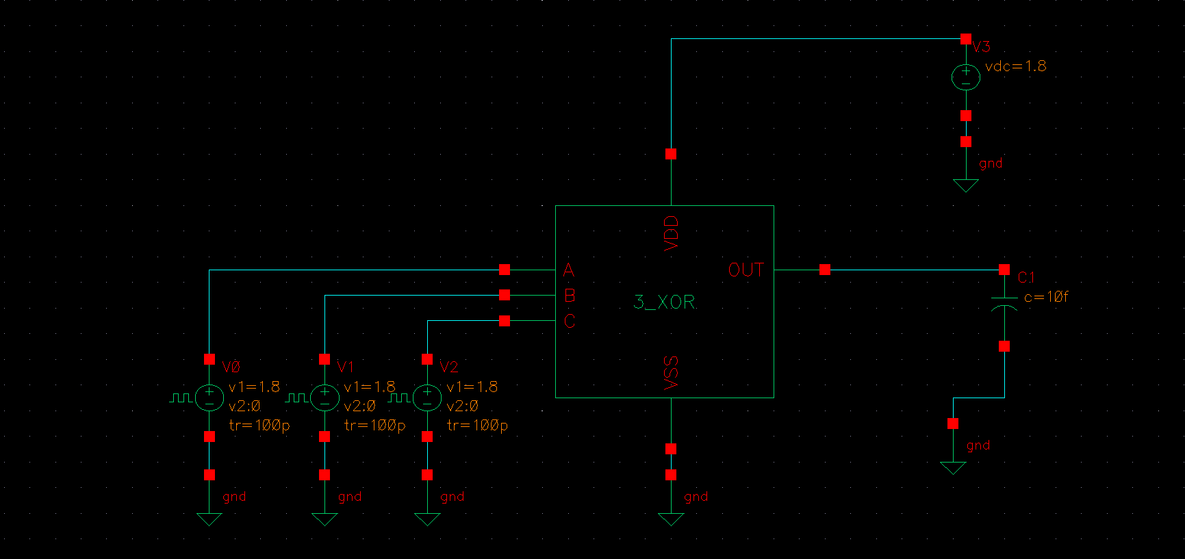

➢ PRE WAVE SIMULATION WAVEFORM
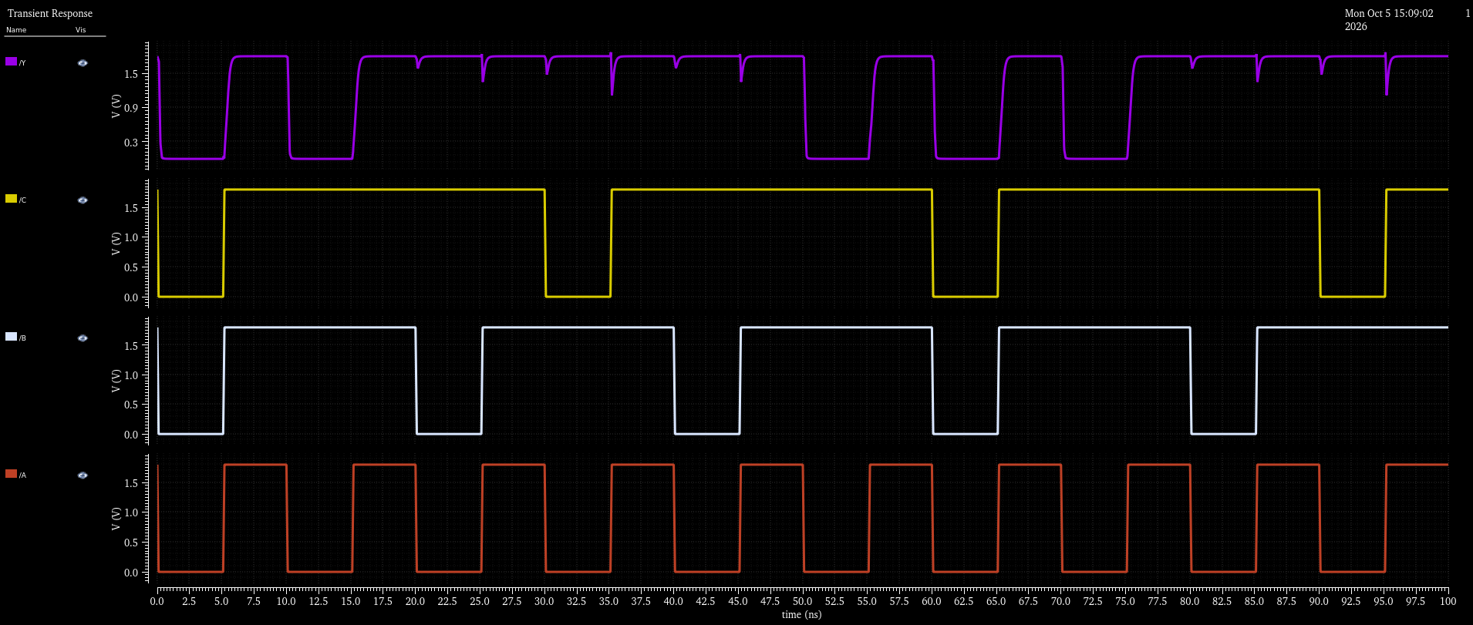

D-LATCH

- SCHEMATIC

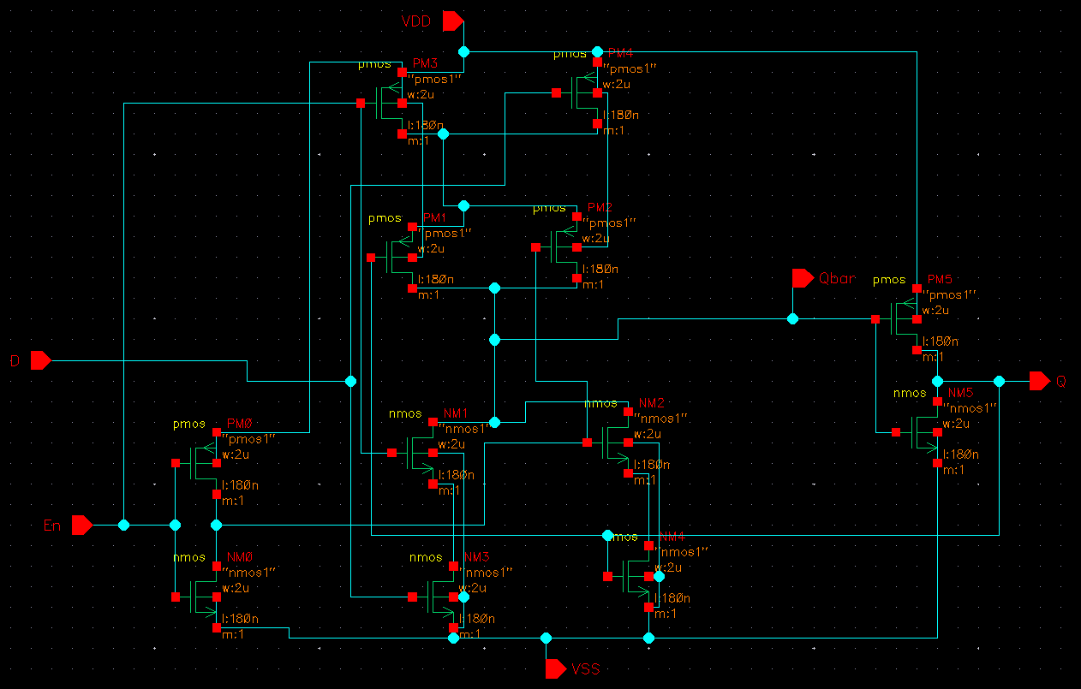

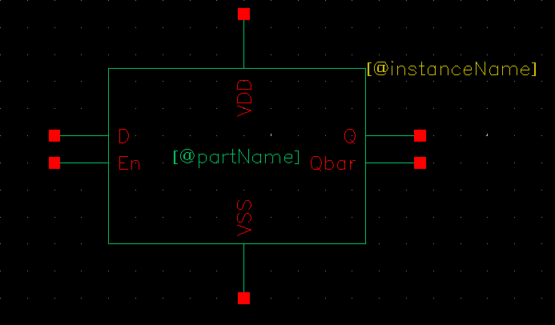

- TESTBENCH

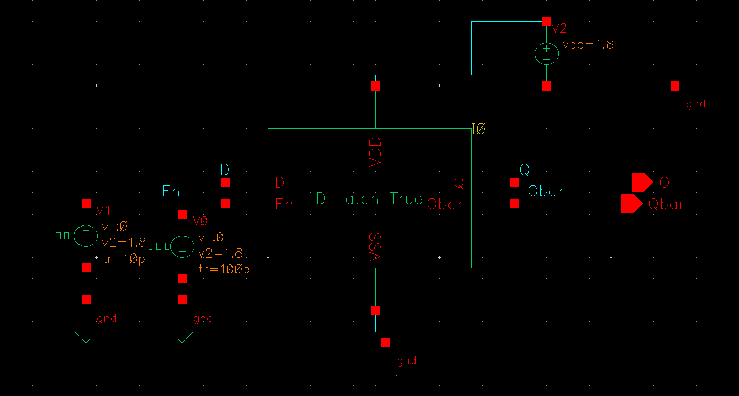

➢ PRELAYOUT SIMULATION
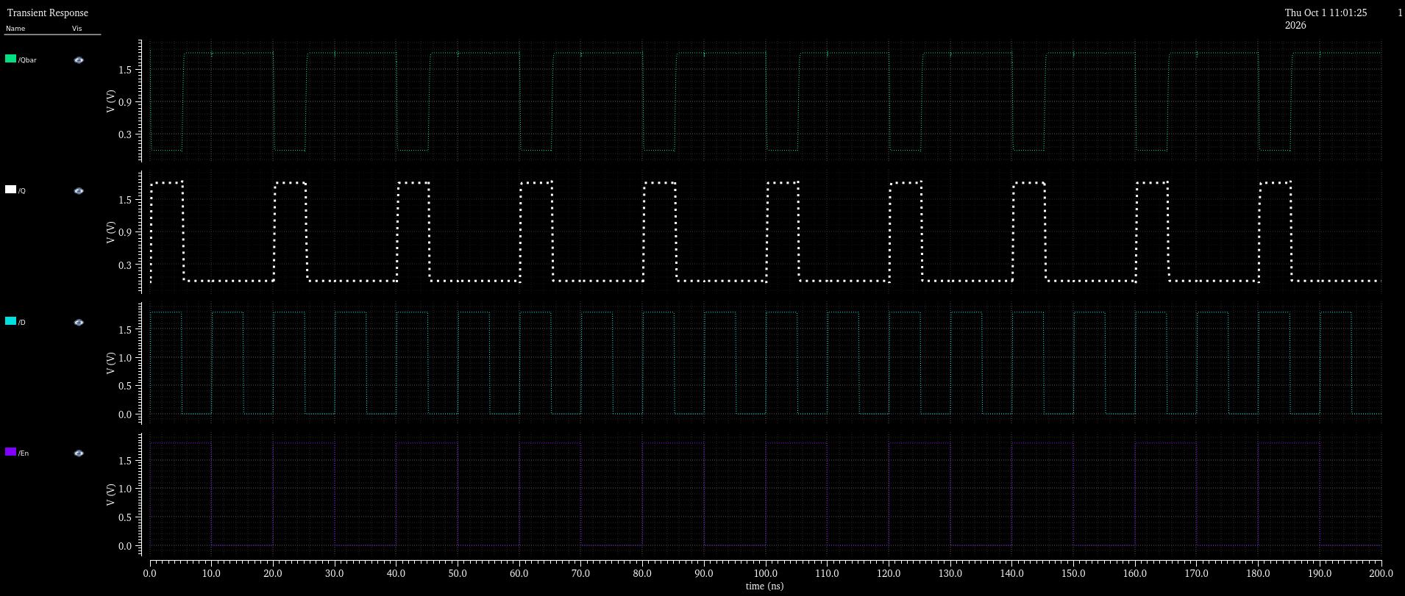

- LAYOUT
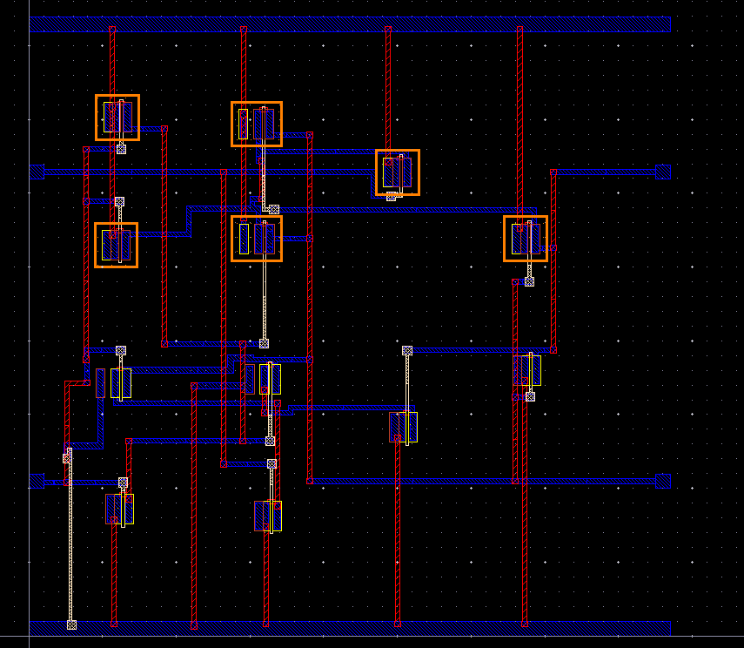

➢ DRC AND LVS COMPLETION

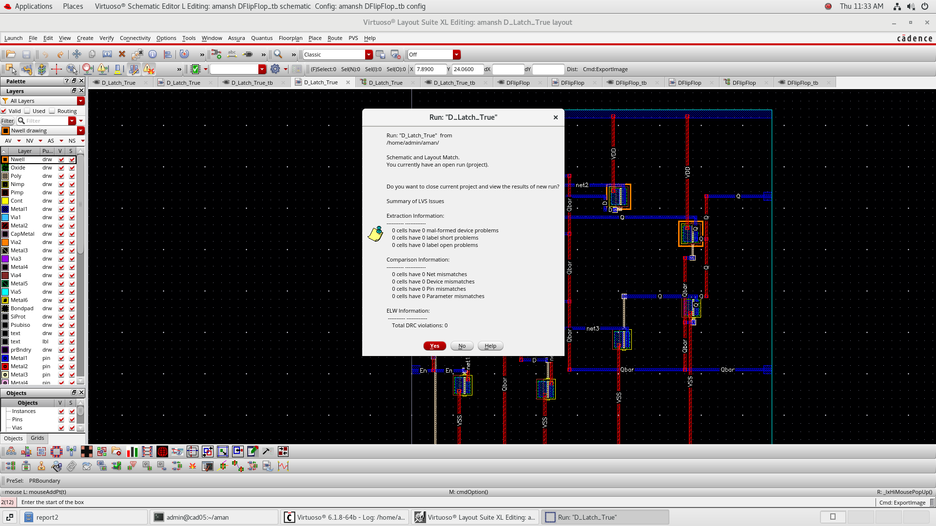

- POSTLAYOUT SIMULATION
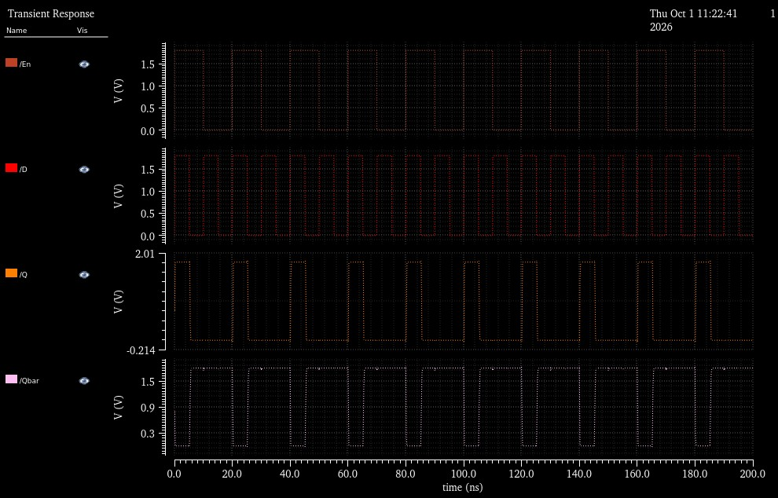

The D-Latch was implemented at transistor level using CMOS logic and verified through schematic-level testbench simulation. The pre-layout waveform demonstrates the controlled transfer of the input data to the output based on the enable signal. The corresponding physical layout was subsequently implemented and subjected to DRC and LVS verification, followed by post-layout simulation to validate the functionality after physical implementation.
MASTER SLAVE D FLIPFLOP

- SCHEMATIC

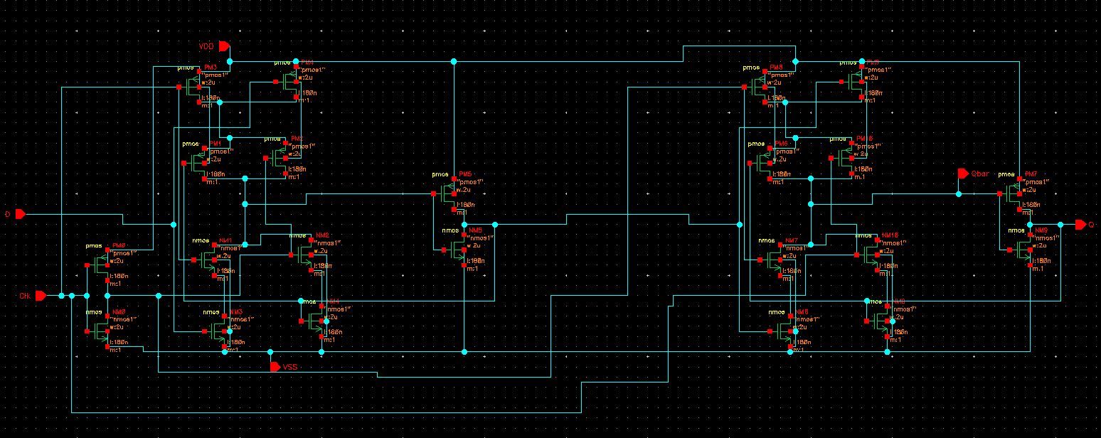

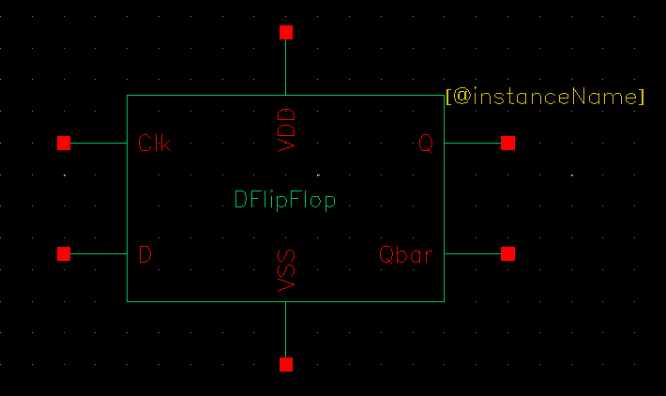

TESTBENCH
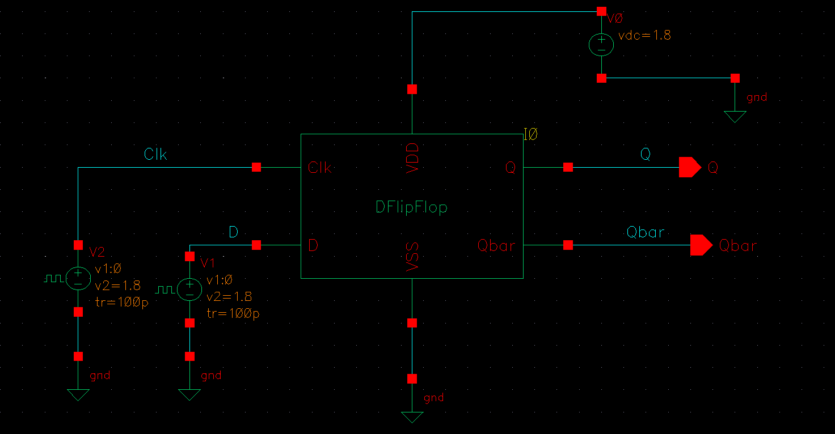

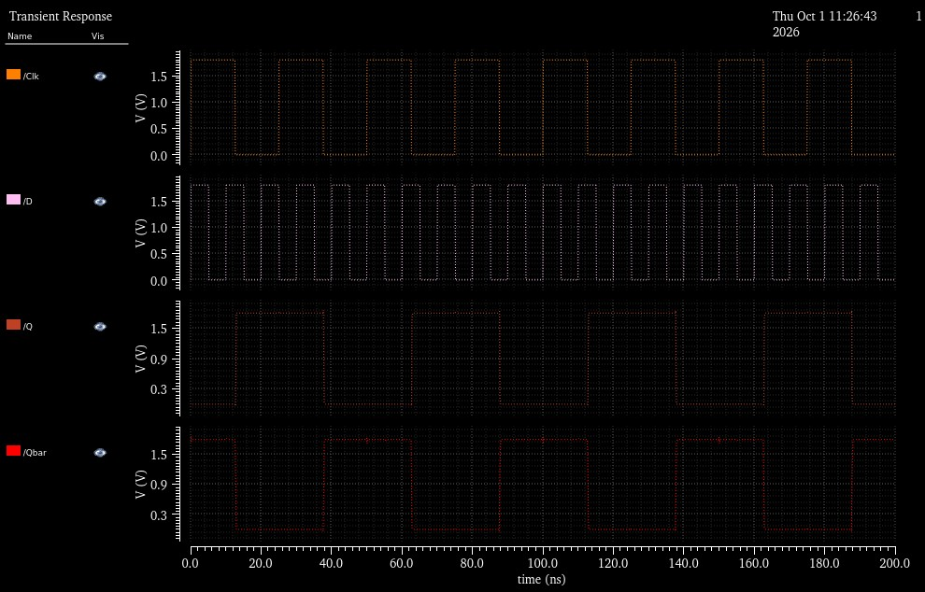

- LAYOUT
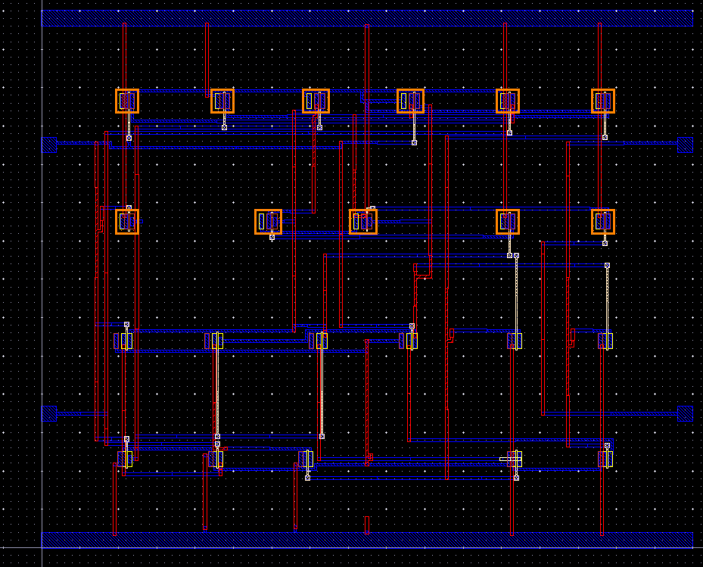

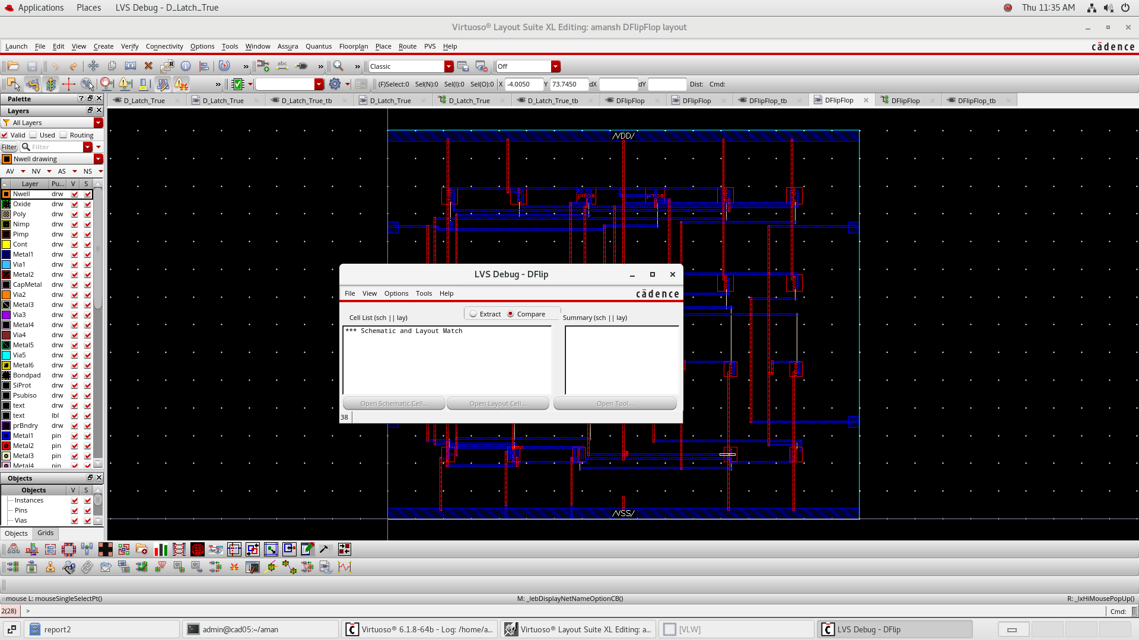

- POSTLAYOUT SIMULATION
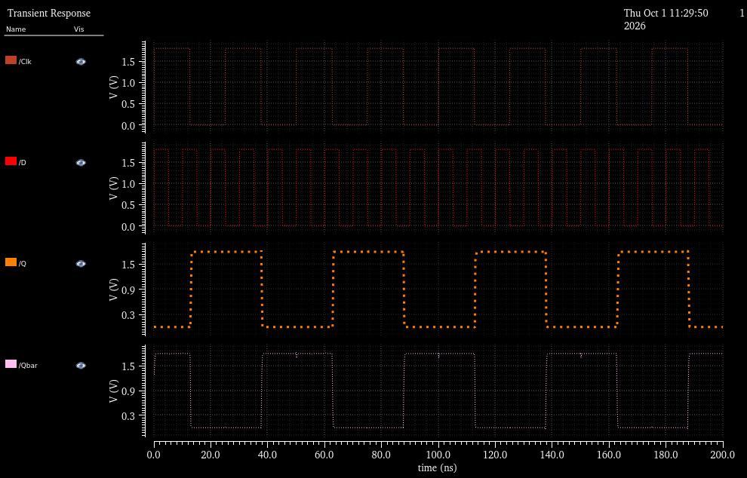

The Master-Slave D Flip-Flop was realized using cascaded storage stages to achieve controlled sequential data transfer. The schematic and testbench were verified through pre-layout simulation, followed by transistor-level layout implementation. DRC and LVS verification were performed to ensure physical and schematic consistency, while post-layout simulation was used to confirm the functional behavior of the implemented sequential circuit

REGISTER 4-BIT

- SCHEMATIC
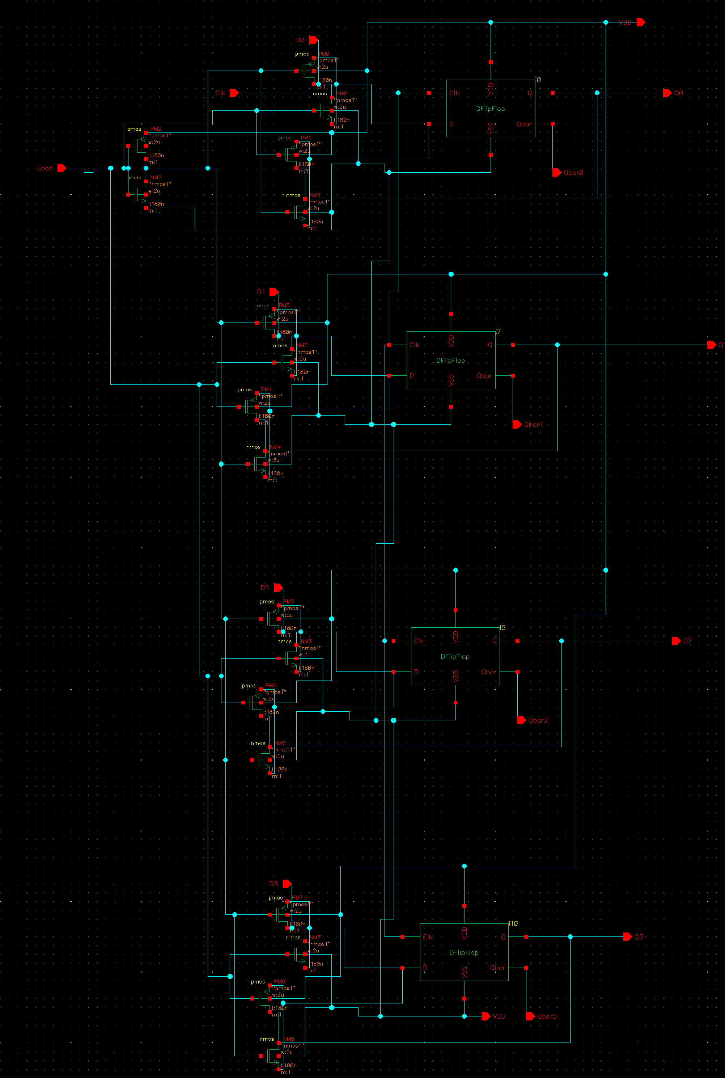
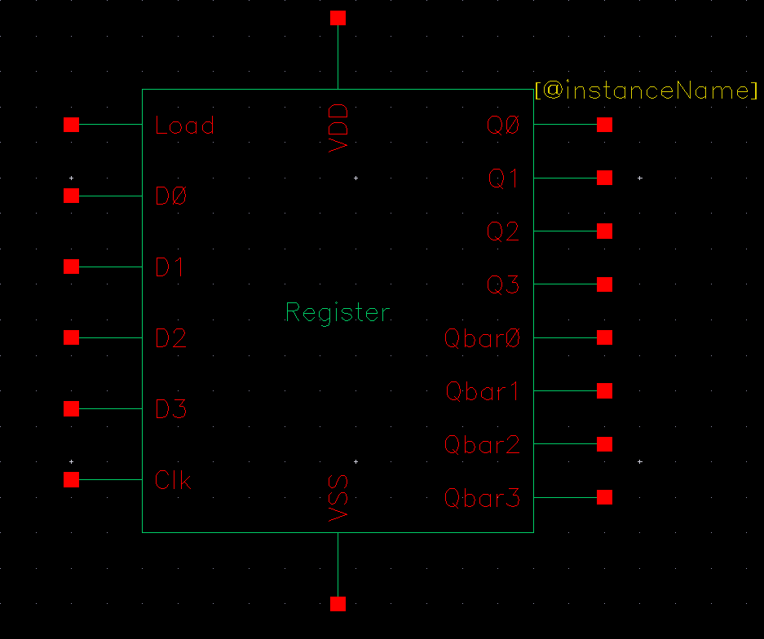

- TESTBENCH

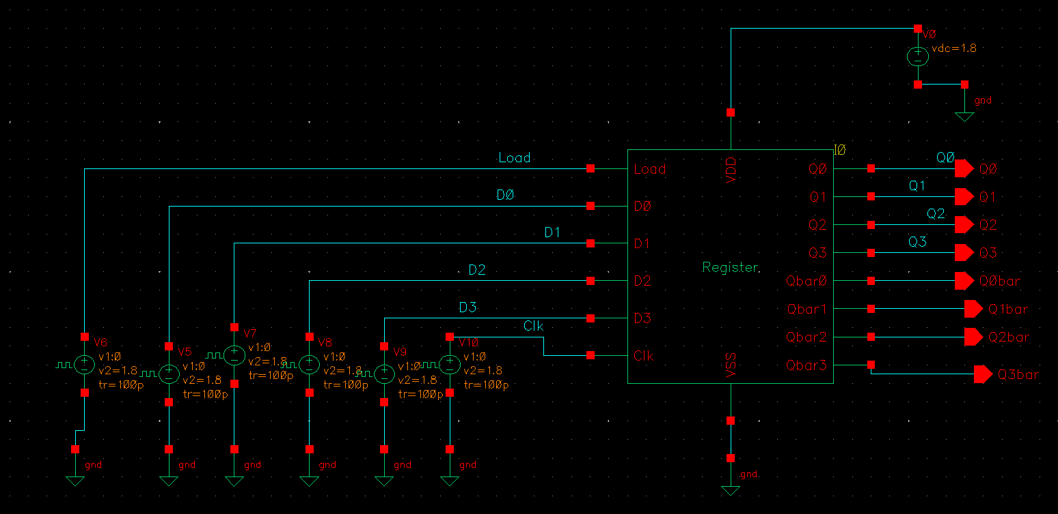

➢ PRELAYOUT SIMULATION

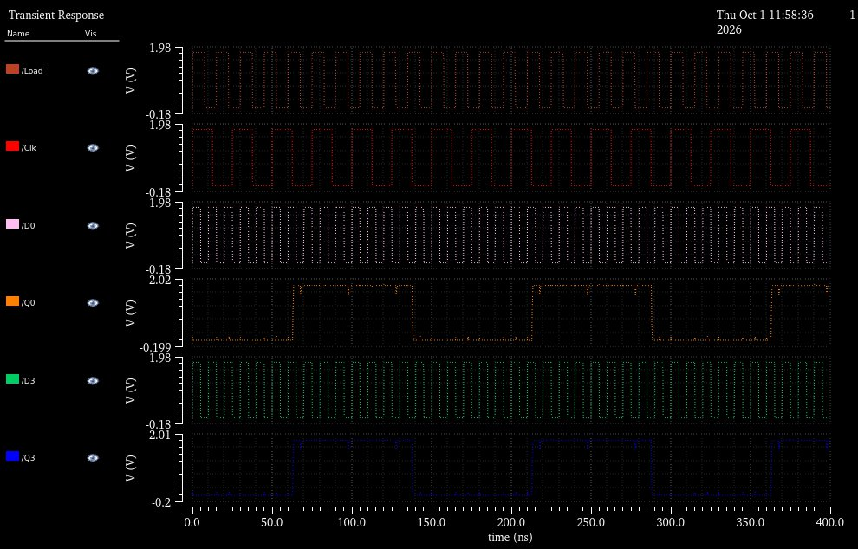

- LAYOUT
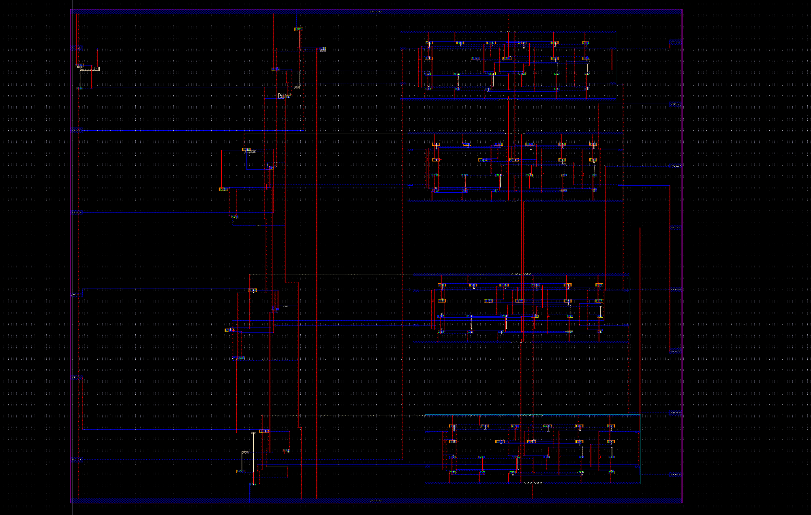

➢ DRC AND LVS COMPLETION
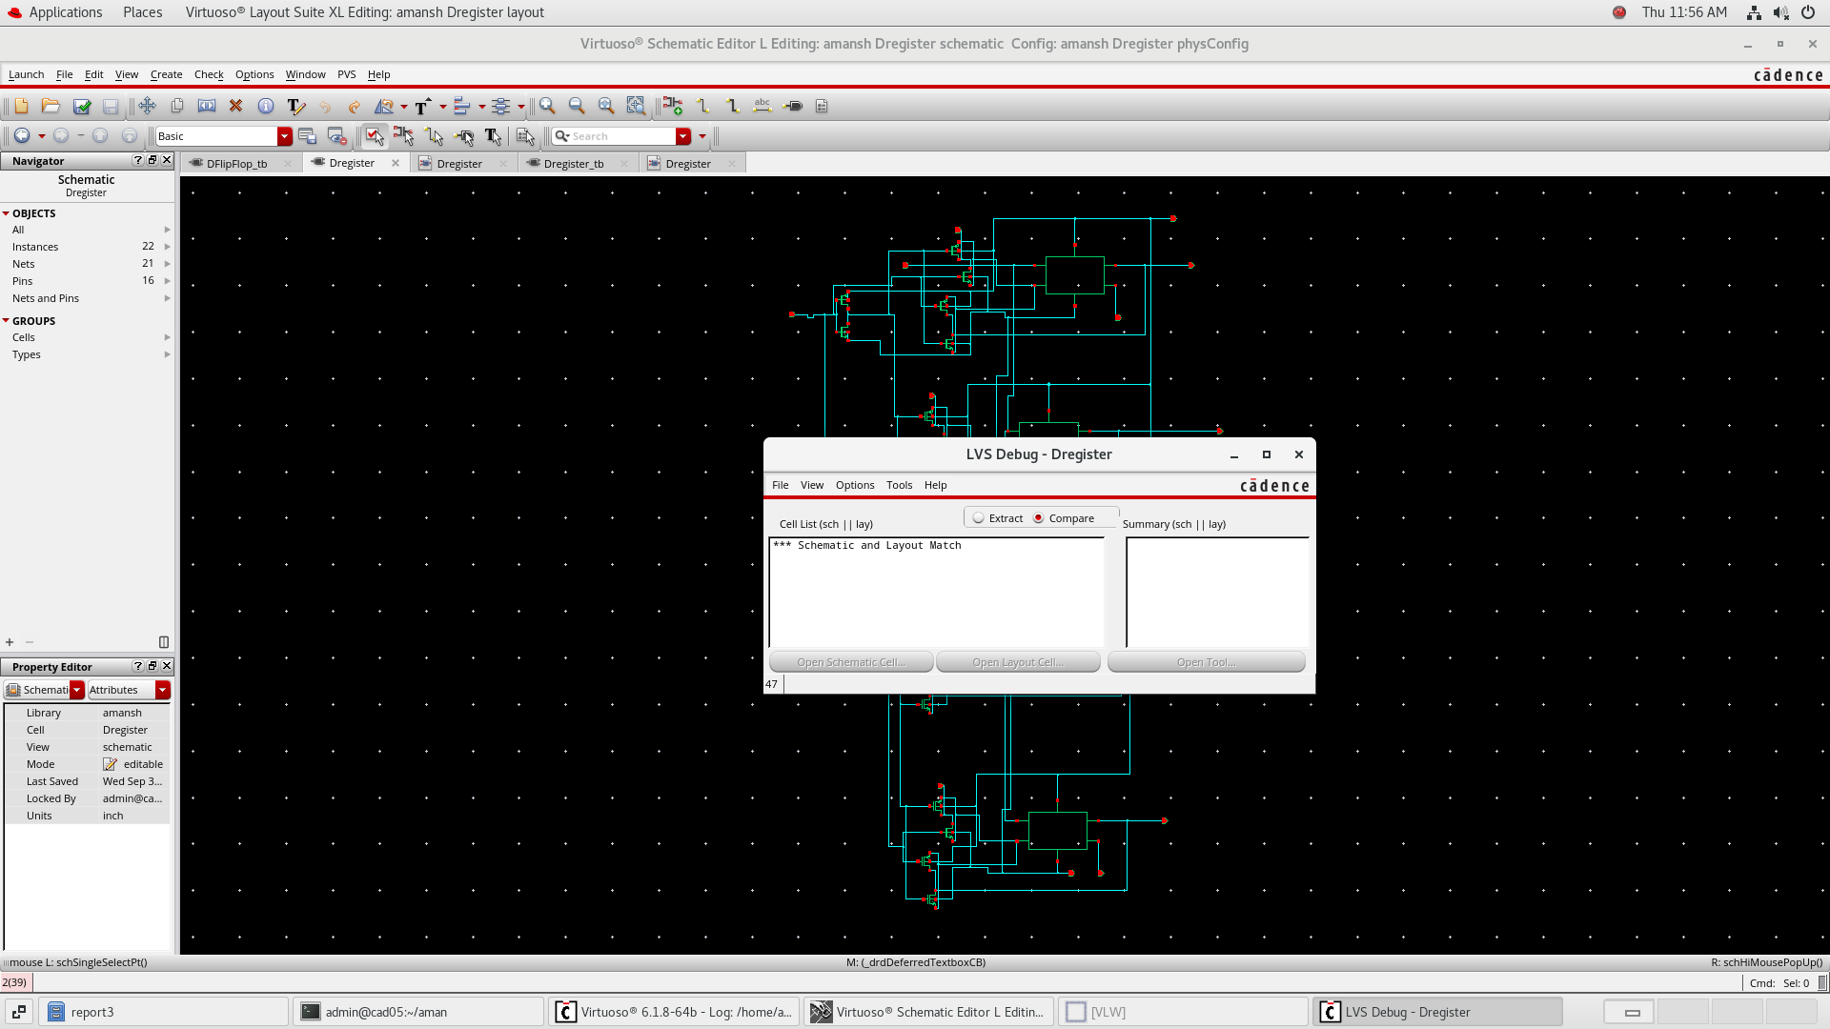

- POSTLAYOUT SIMULATION

The 4-bit Register was developed as a multi-bit sequential storage structure capable of retaining four individual data bits. The implemented schematic was integrated with a dedicated testbench and evaluated through pre-layout transient simulation. The physical layout was then constructed and verified using DRC and LVS before performing post-layout simulation, establishing the complete custom-design flow from logical functionality to physical realization.
COUNTER 8 BIT

- SCHEMATIC
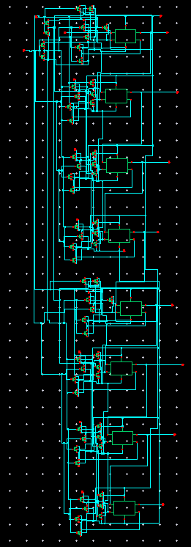

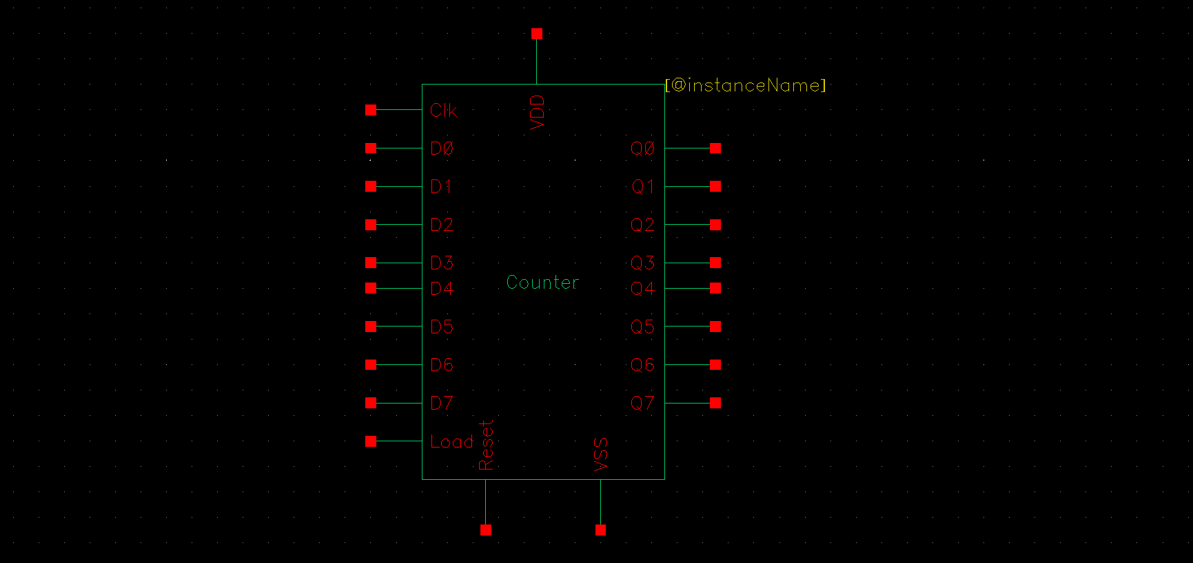

- TESTBENCH
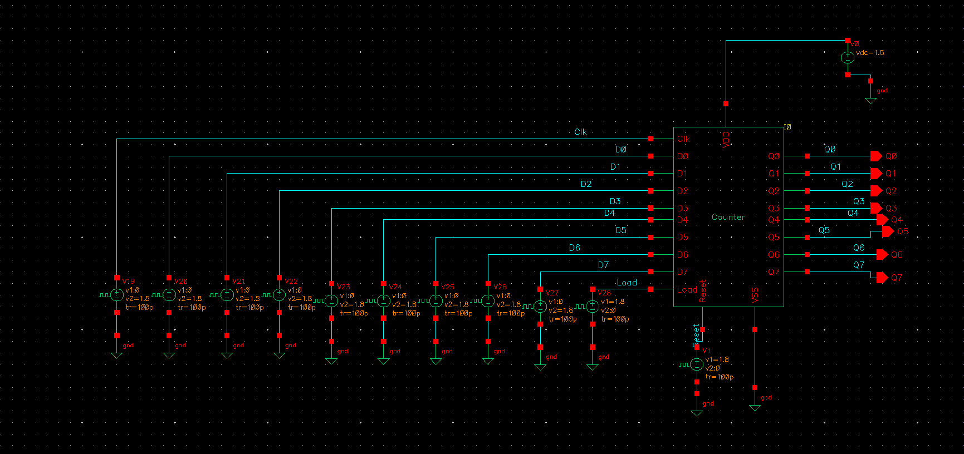

➢ PRELAYOUT SIMULATION
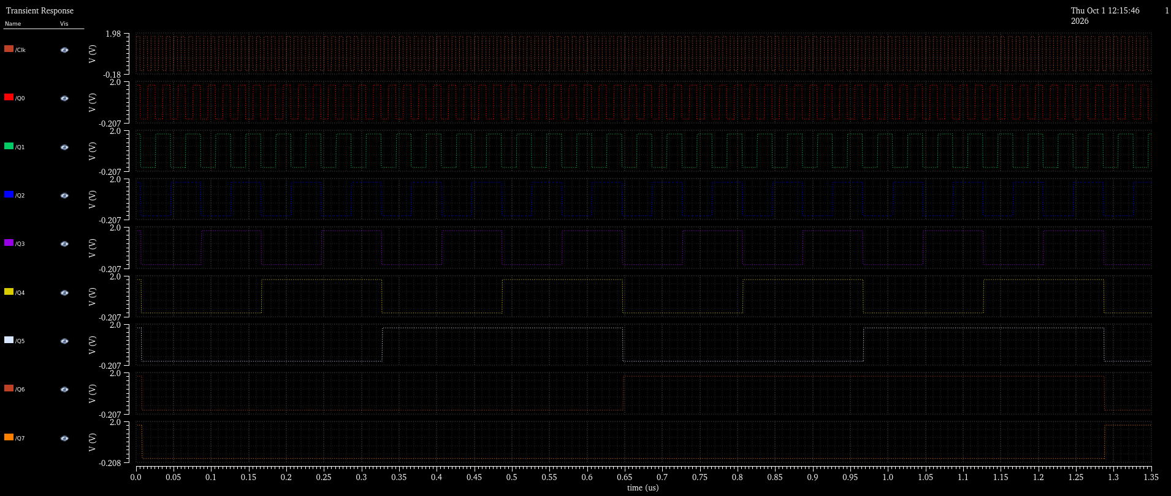

- LAYOUT
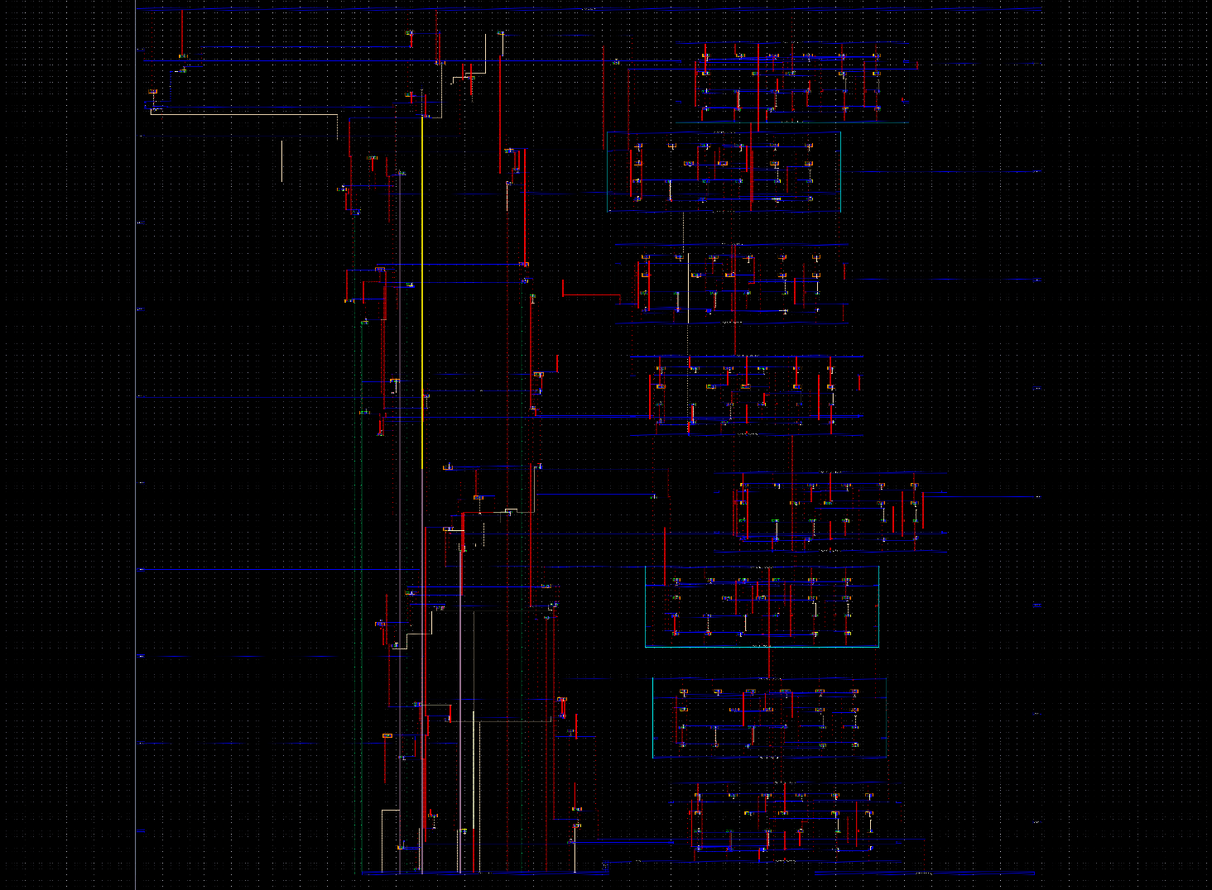

➢ DRC AND LVS COMPLETION

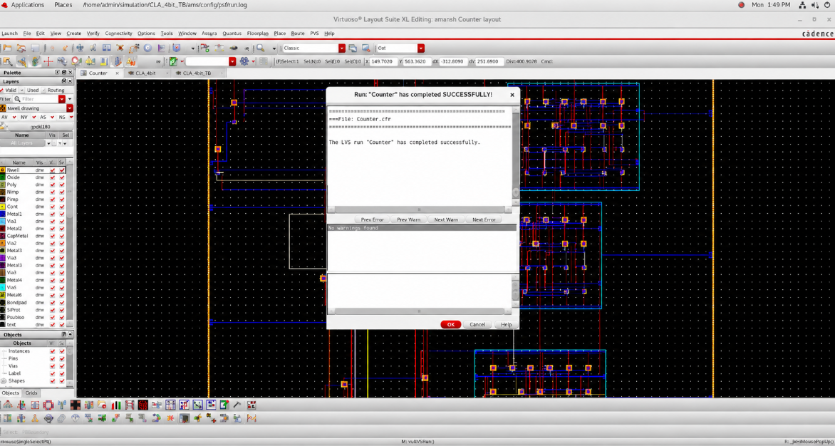

- POSTLAYOUT SIMULATION
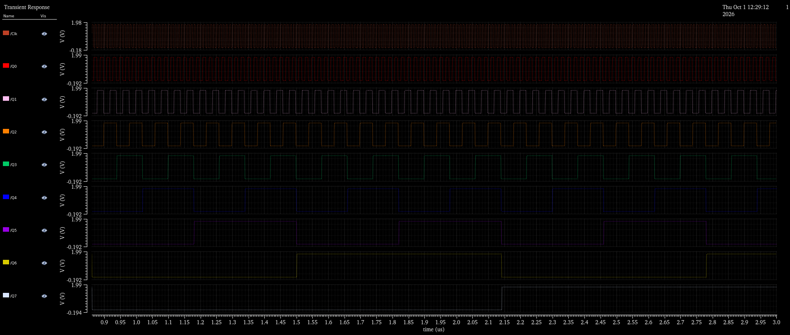

The 8-bit Counter was implemented as a transistor-level sequential digital block with eight output states representing the counter operation. The testbench applies the required input and clock conditions, while the pre-layout transient waveform demonstrates the coordinated switching activity across the output bits. The design was subsequently converted into physical layout, verified through DRC and LVS, and evaluated through post-layout simulation to validate its operation after physical implementation.
The report images specifically show the eight output nodes Q0–Q7 and their corresponding switching waveforms.

- SCHEMATIC

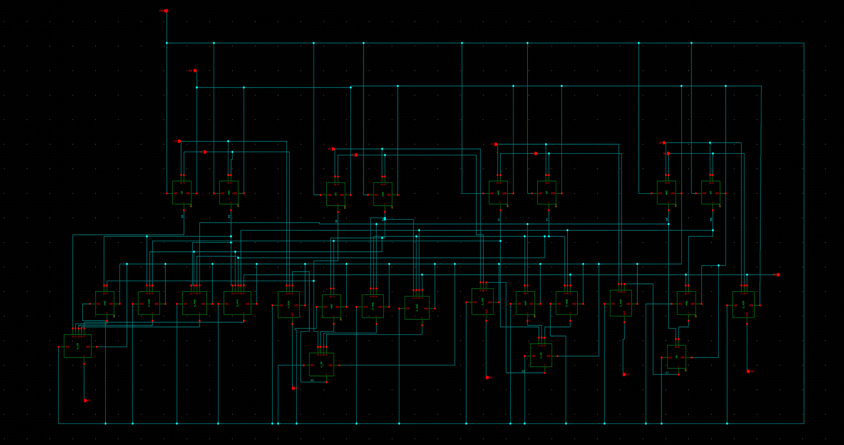

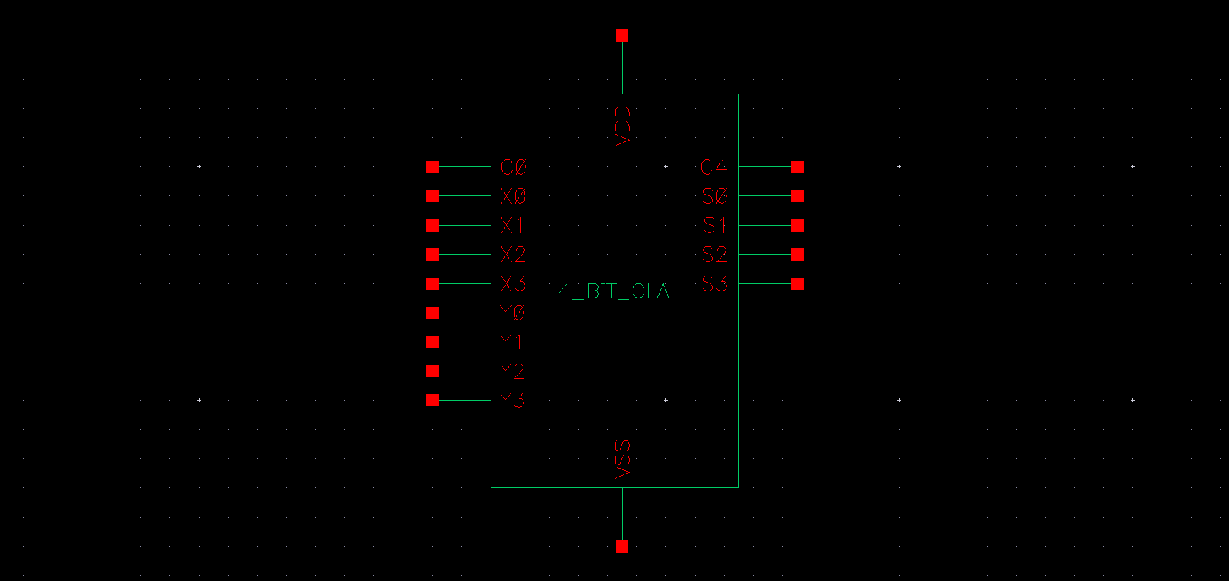

- TESTBENCH

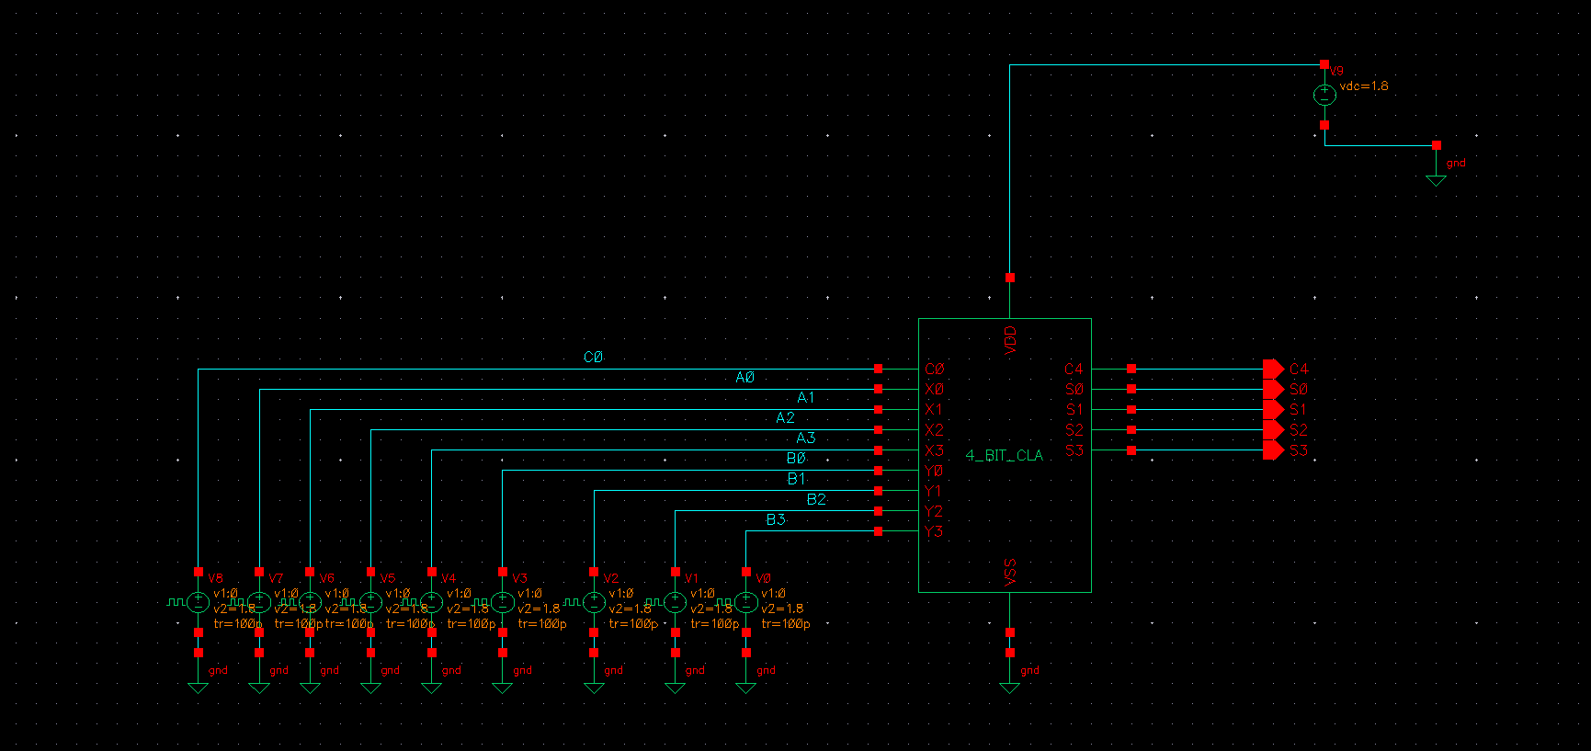

➢ PRELAYOUT SIMULATION

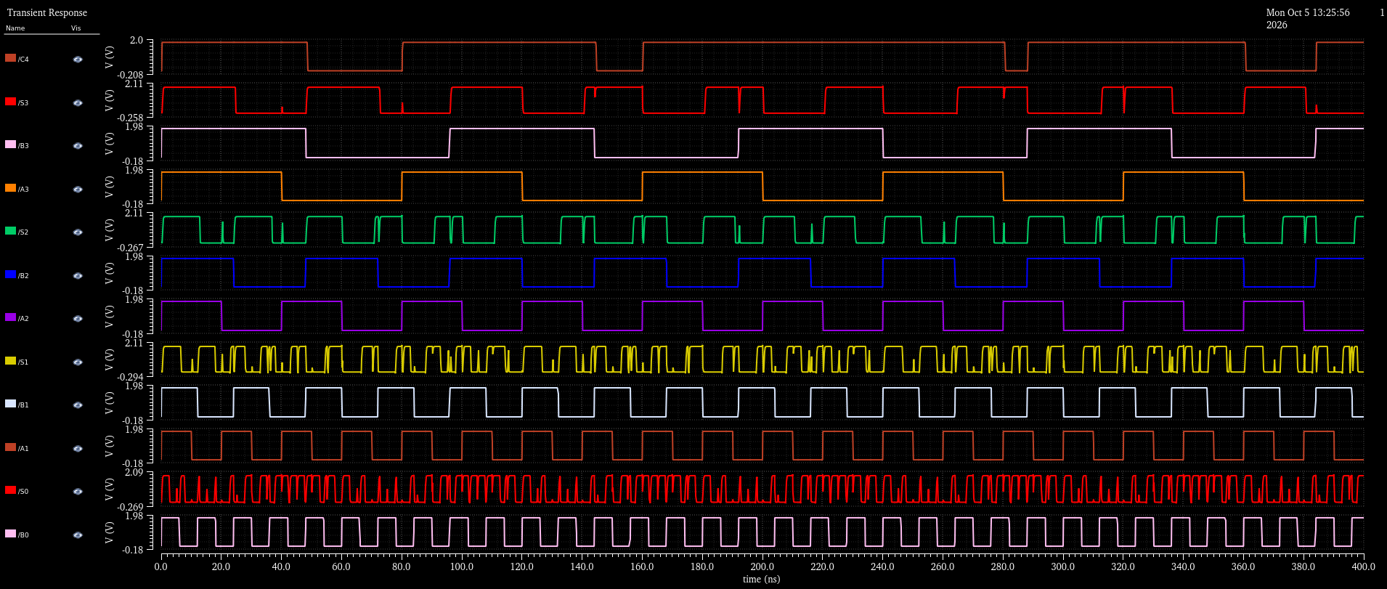

- LAYOUT

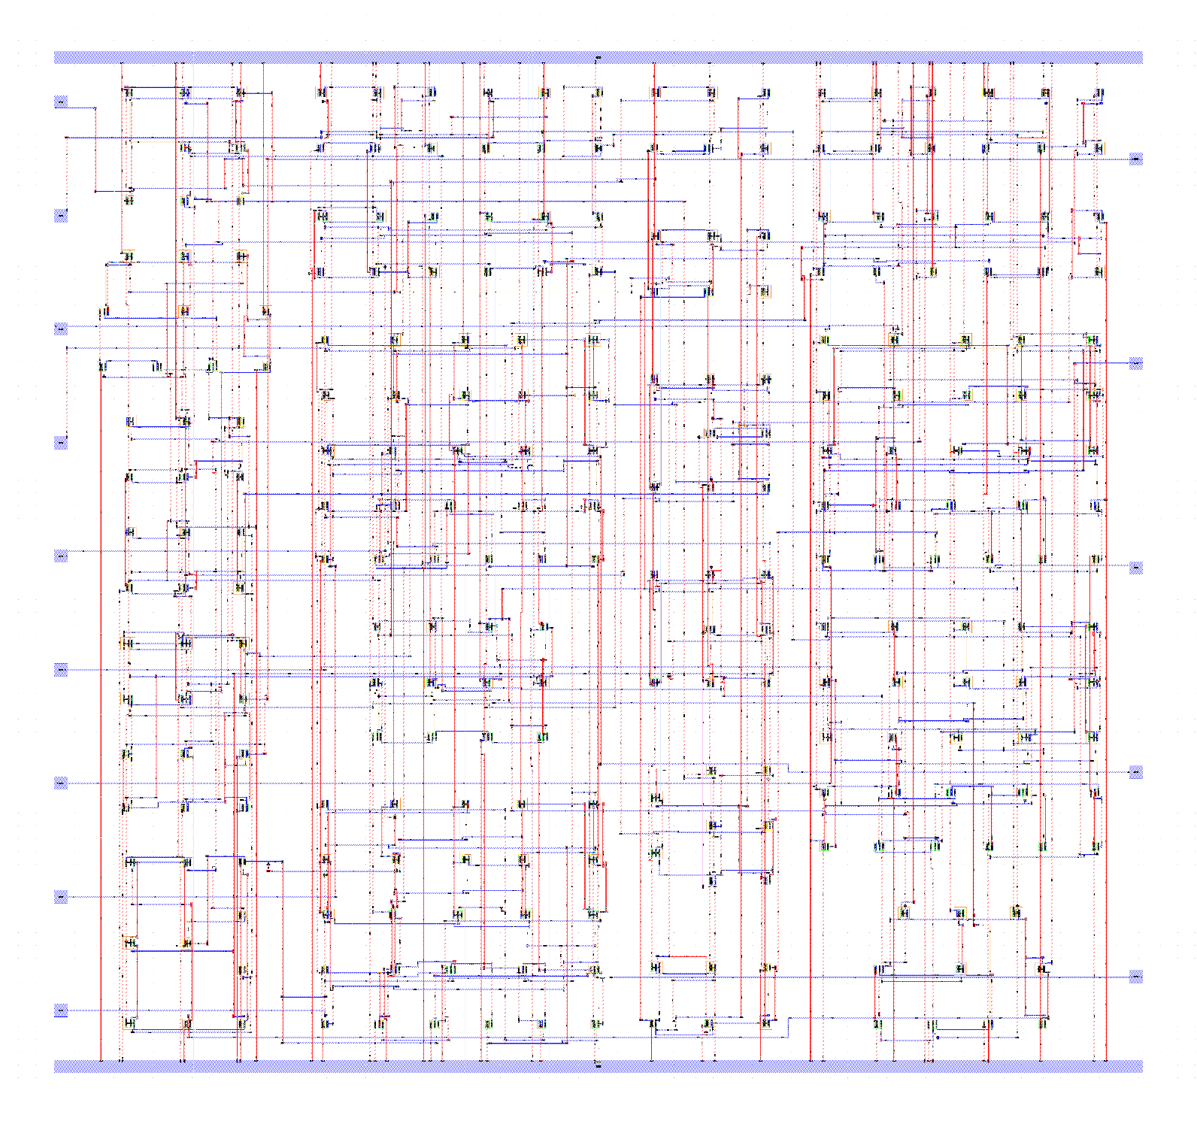

➢ DRC AND LVS COMPLETION

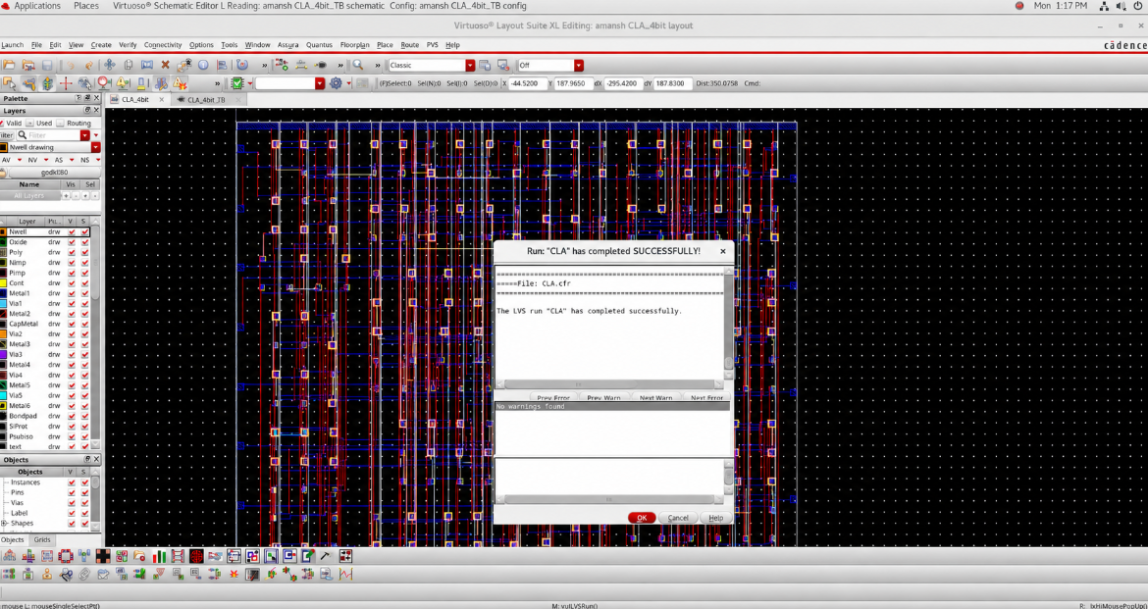
➢POST LAYOUT SIMULATION

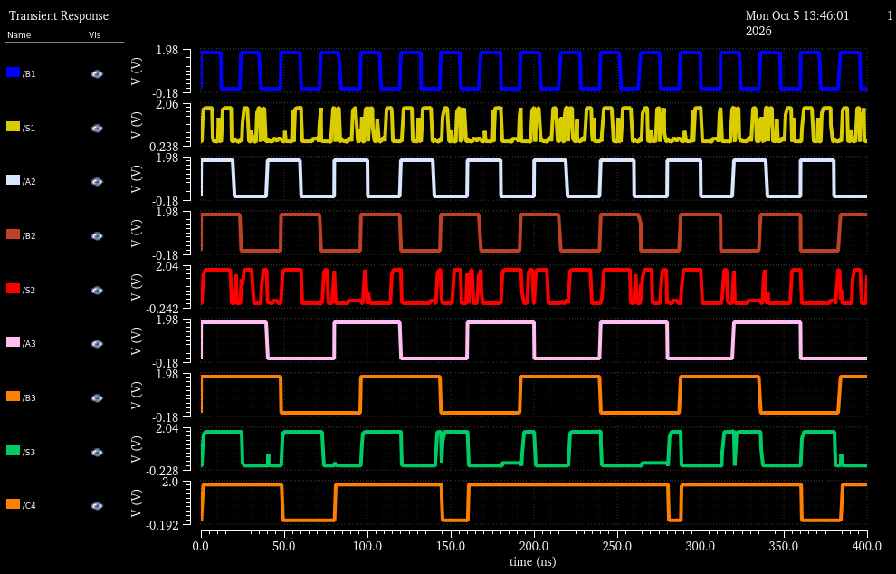

The 4bit Carry Look-Ahead Adder was implemented using 2-input, 3-input, 4-input and 5-input AND and OR gates along with 3-input XOR gates. The circuit generates the required propagate and generate signals for each bit and uses them to determine the carry signals C1, C2, C3 and C4 through parallel carry propagation. This reduces the carry dependency between successive stages compared with a conventional ripple-carry structure. The design was verified through pre-layout and post-layout simulations, with the physical implementation validated using DRC and LVS.

➢ CONCLUSION:
The implementation of these circuits established a complete full-custom CMOS VLSI design flow, progressing from transistor-level circuit conception to physically verified silicon-oriented realization. The D-Latch and Master-Slave D Flip-Flop formed the sequential building blocks, which were extended into the 4-bit Register and 8-bit Counter, while the 4 bit Carry Look Ahead Adder demonstrated the application of custom CMOS design to higher-level arithmetic computation. Each design was developed through schematic capture, functional testbench verification, pre-layout simulation, physical layout, DRC/LVS verification, and post-layout simulation.
The work therefore demonstrates more than the logical operation of individual digital circuits—it establishes the transition from Boolean functionality to transistor-level implementation and finally to layout-aware circuit verification. The successful correlation of schematic, physical design, and post-layout behavior highlights the fundamental principle of full-custom VLSI: a circuit is not considered complete when its logic is correct, but when its functionality survives the journey from abstraction to physical geometry. This workflow provides a practical foundation for designing compact, reliable and verification-driven CMOS digital systems at the IC level.

